Project

1. Create ADF –

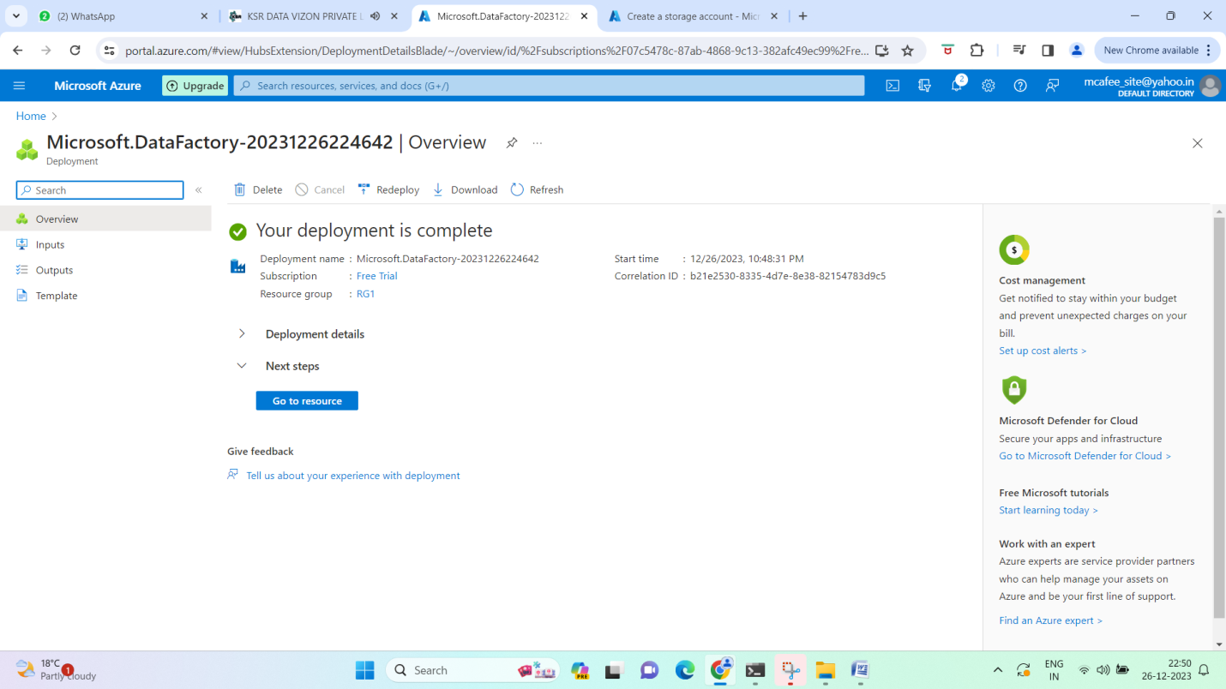

1. Create blob

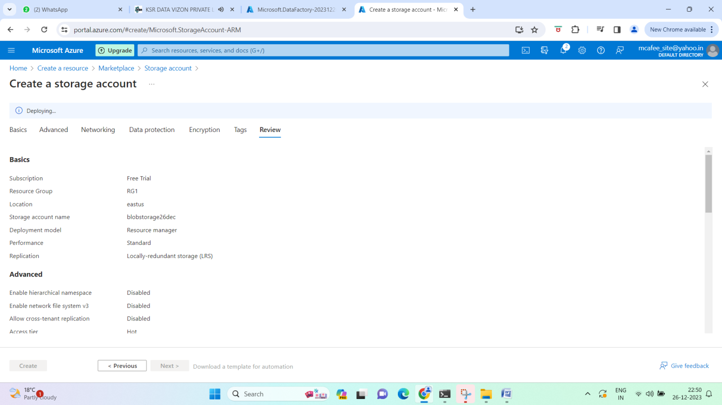

1. Create ADLS

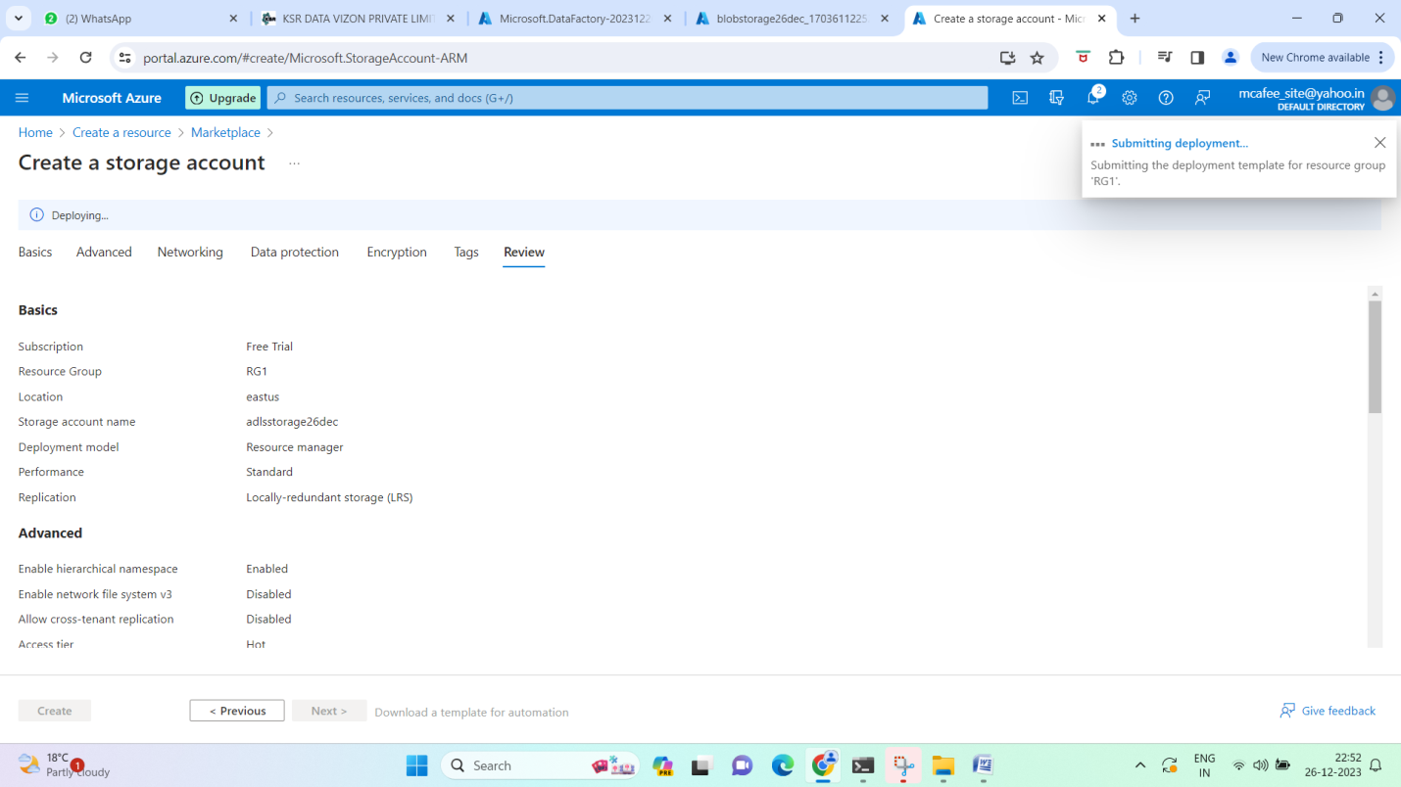

1. Upload files to adls dimension folder

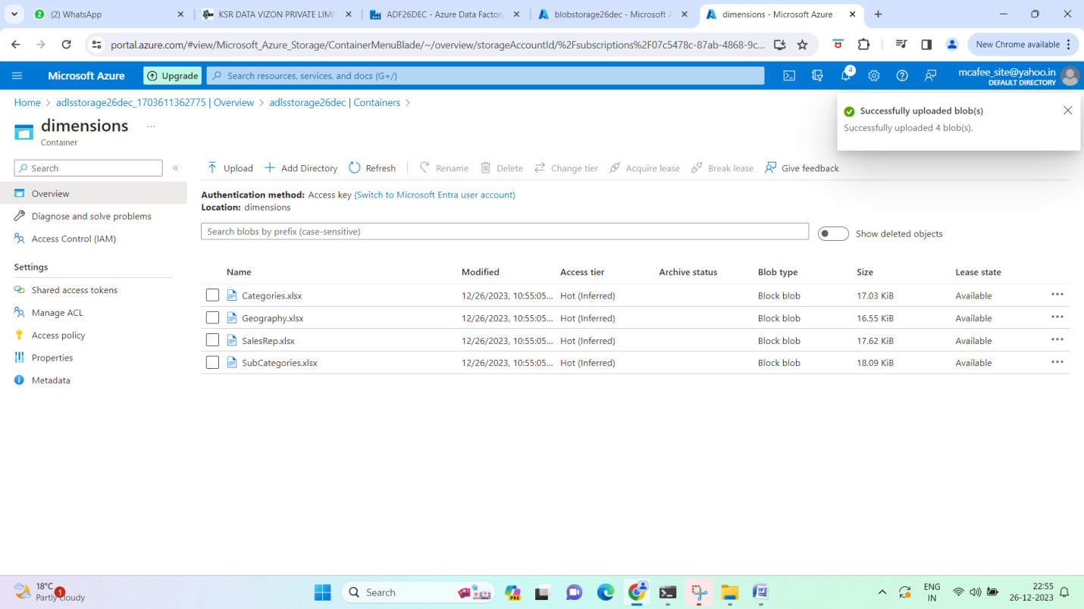

1. In Blob upload sales (fact data)

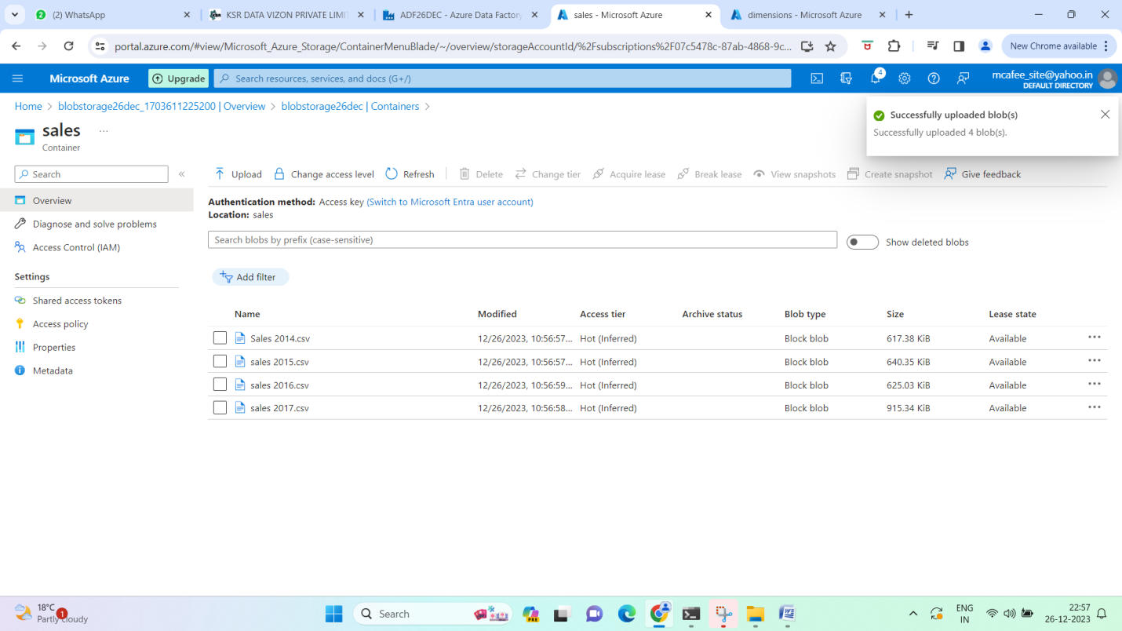

1. Create Linked Service (blobtoadf)

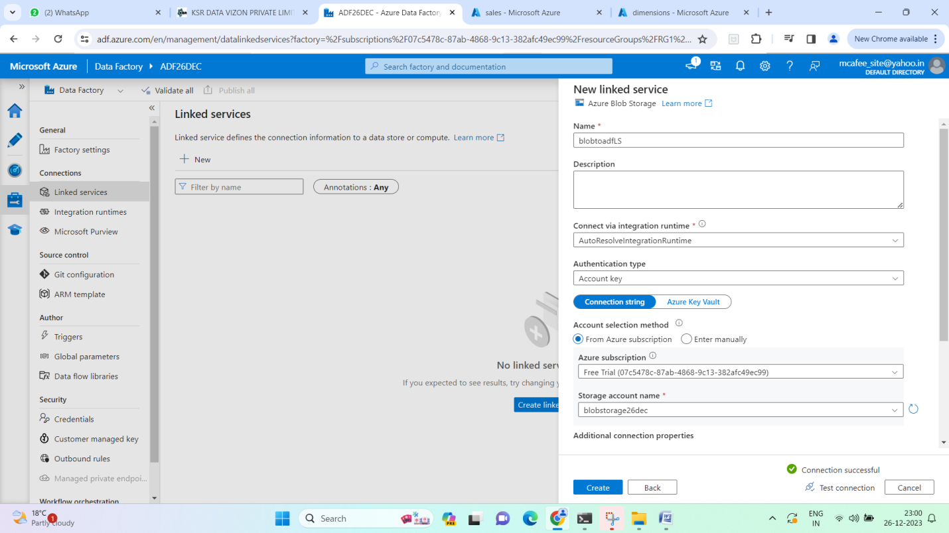

1. Create Linked service (adls to adf)

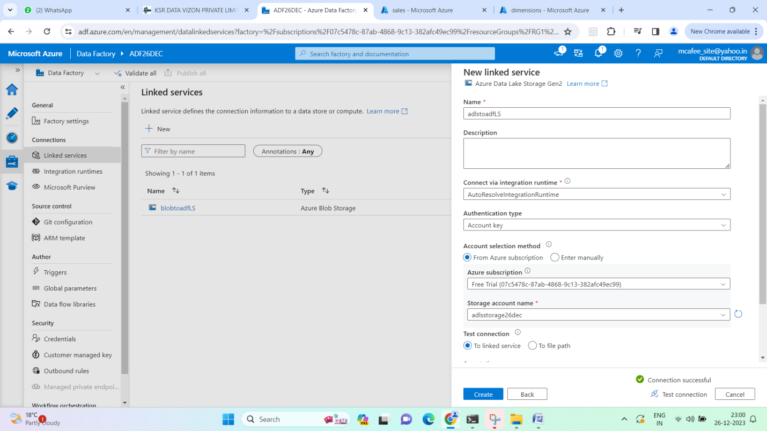

1. Create dataset for categories dimension in adls

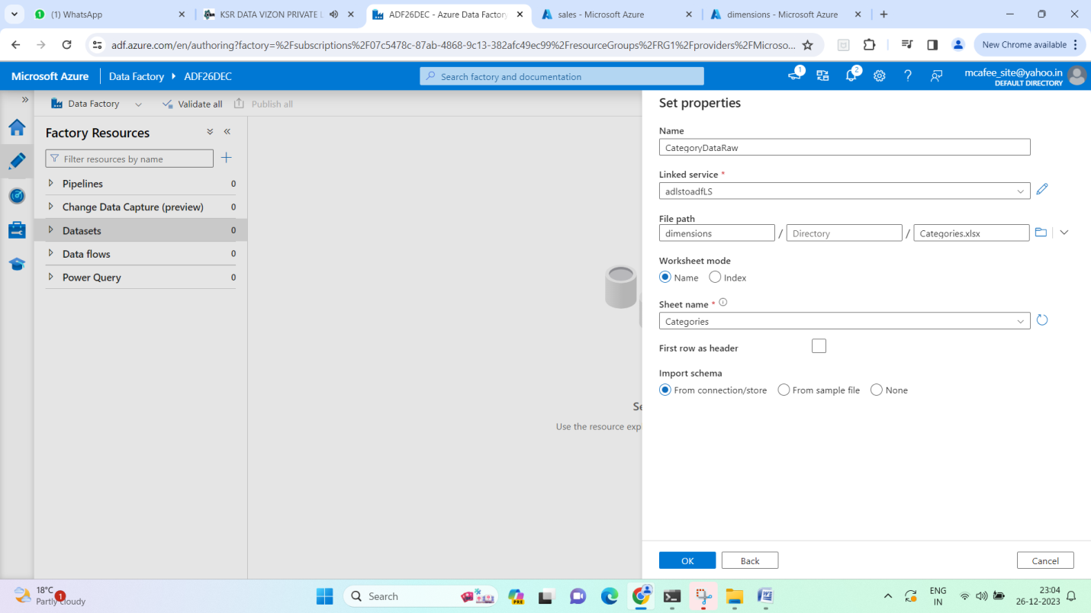

1. create other datasets –

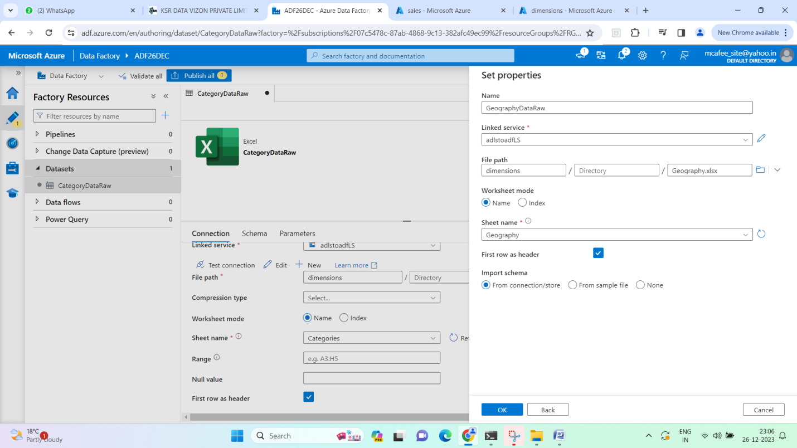

1. Create staging data container in both blob and adls

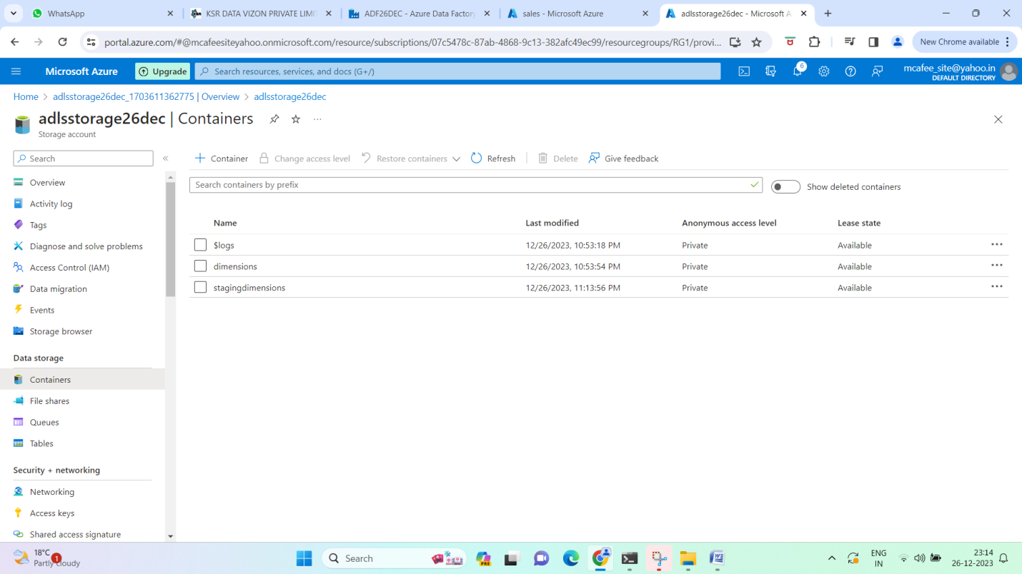

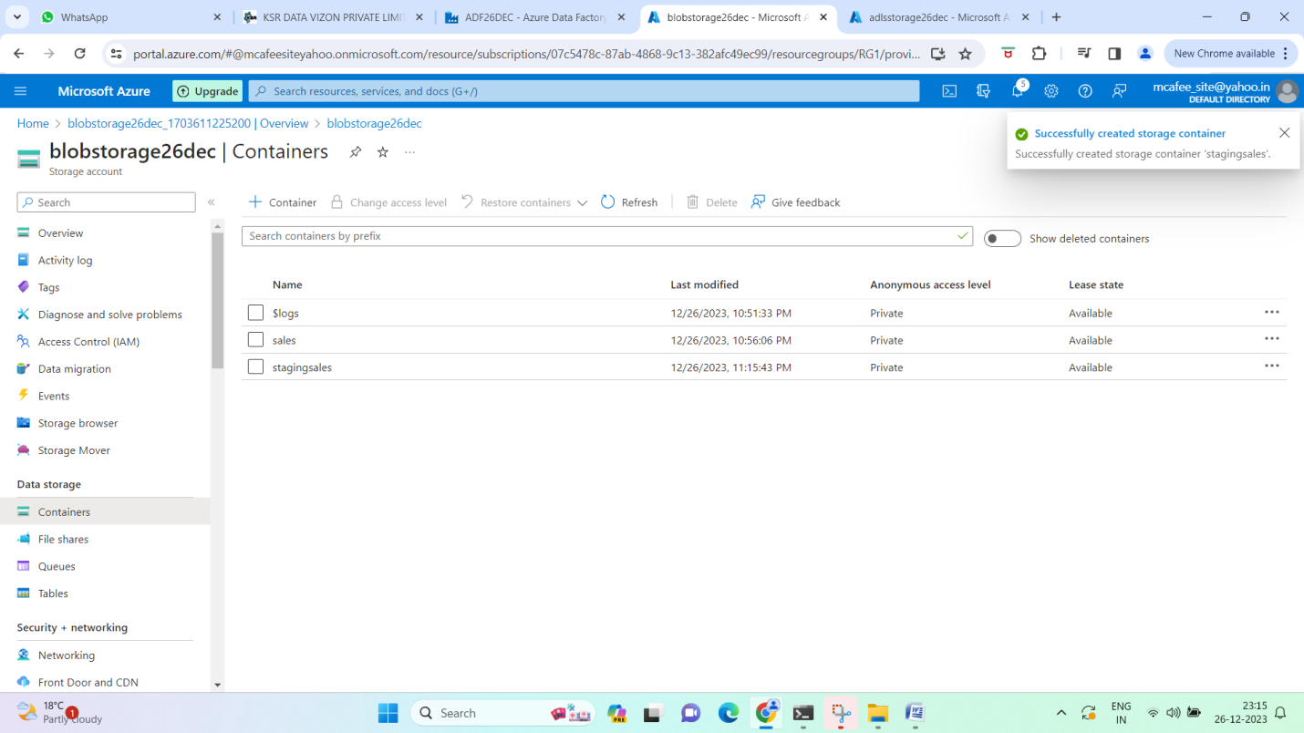

1. Create dataflow for category raw data (do some minor cleansing here if required but just 2 columns here, nothing much to do in this case)

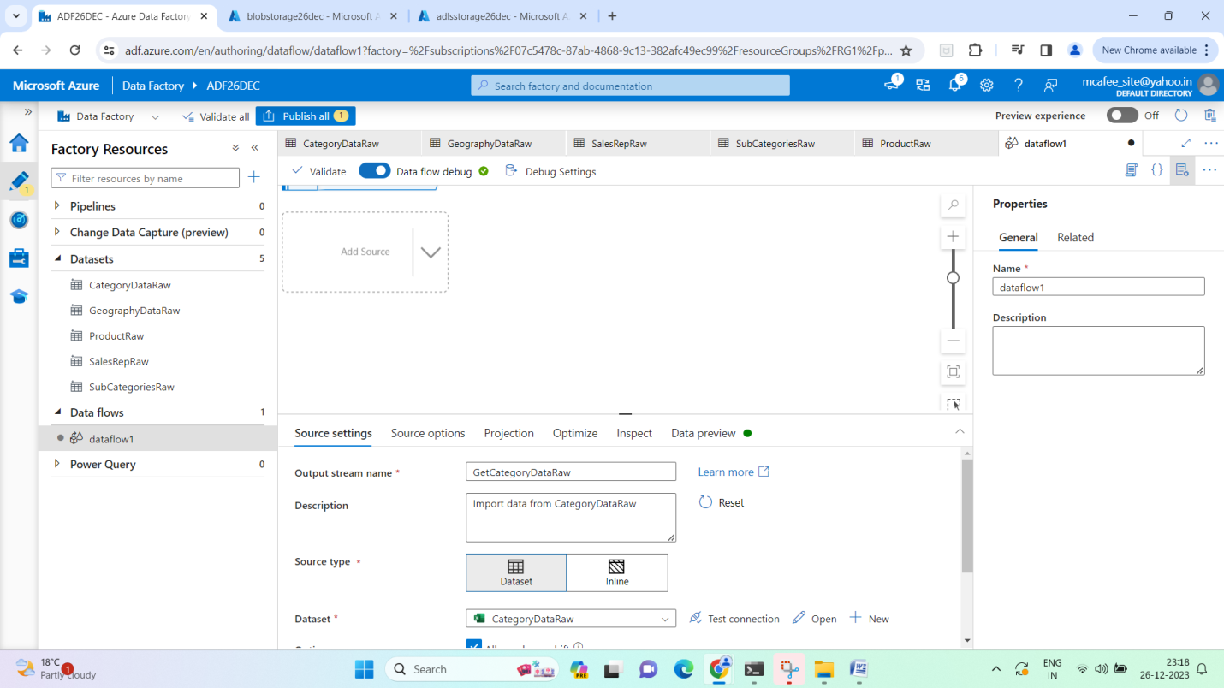

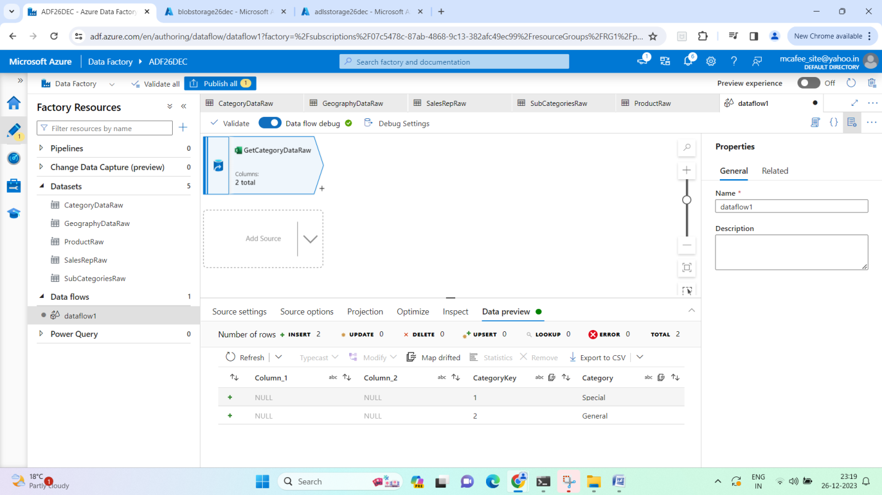



Objective - We are picking data from raw data (dimensions) – minor transform if any – then staging dimensions folder in adls

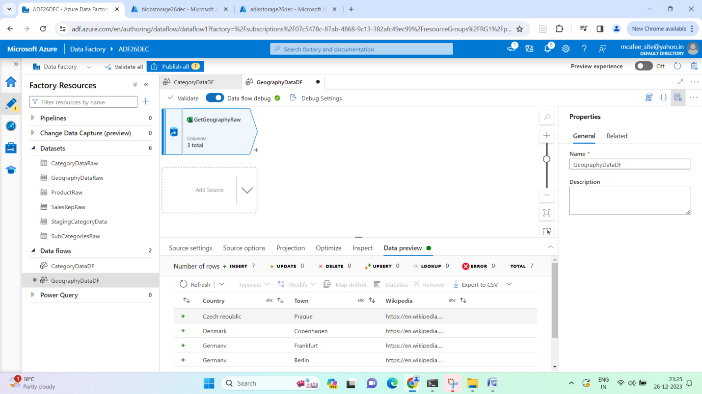

1. Repeat similar operation for other dimension and fact dataset

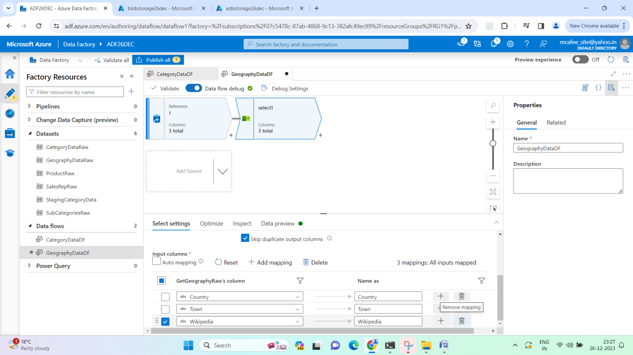

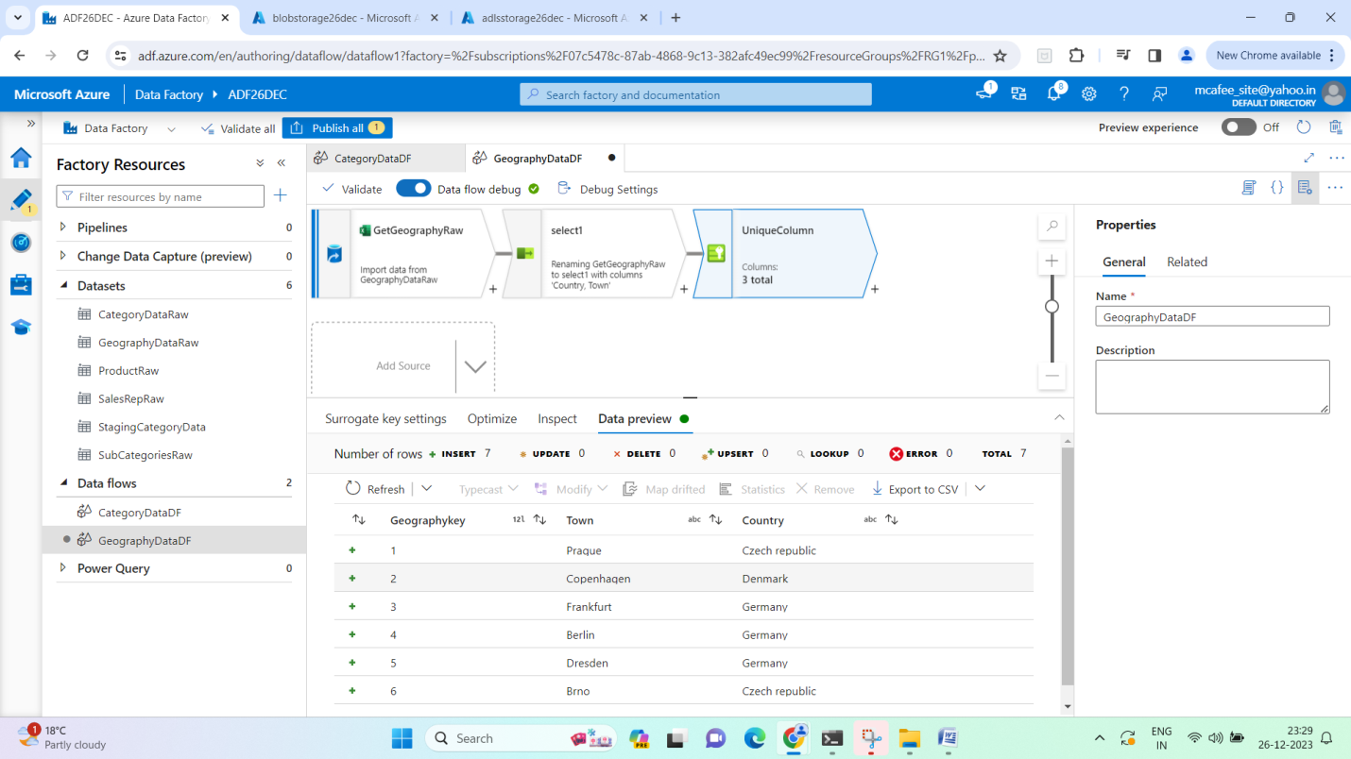

1. Repeat for product Dataset - There are duplicates in product ID (7 & 10)

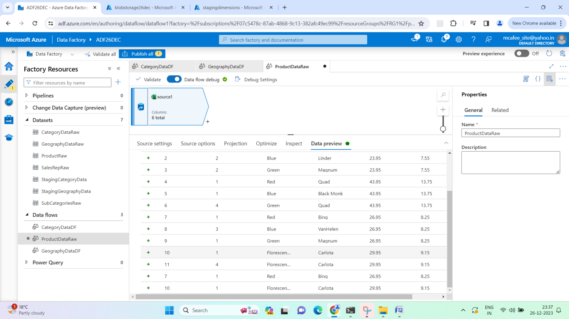

Method to remove duplicates - use an aggregator (grouby, aggregates)

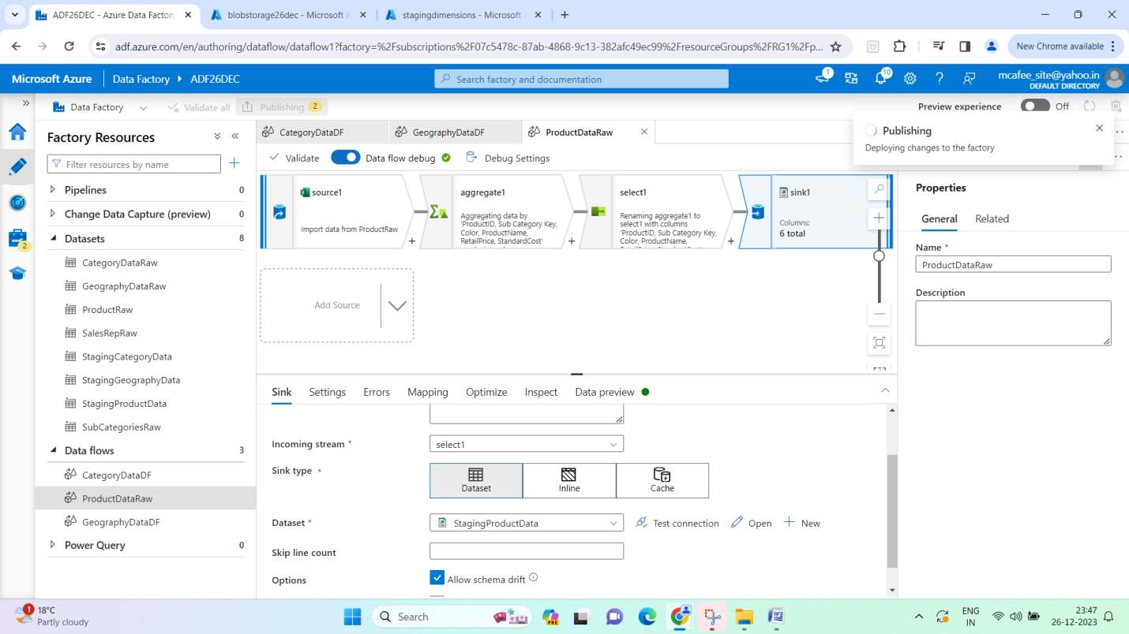

1. For sales_rep > remove ID 6

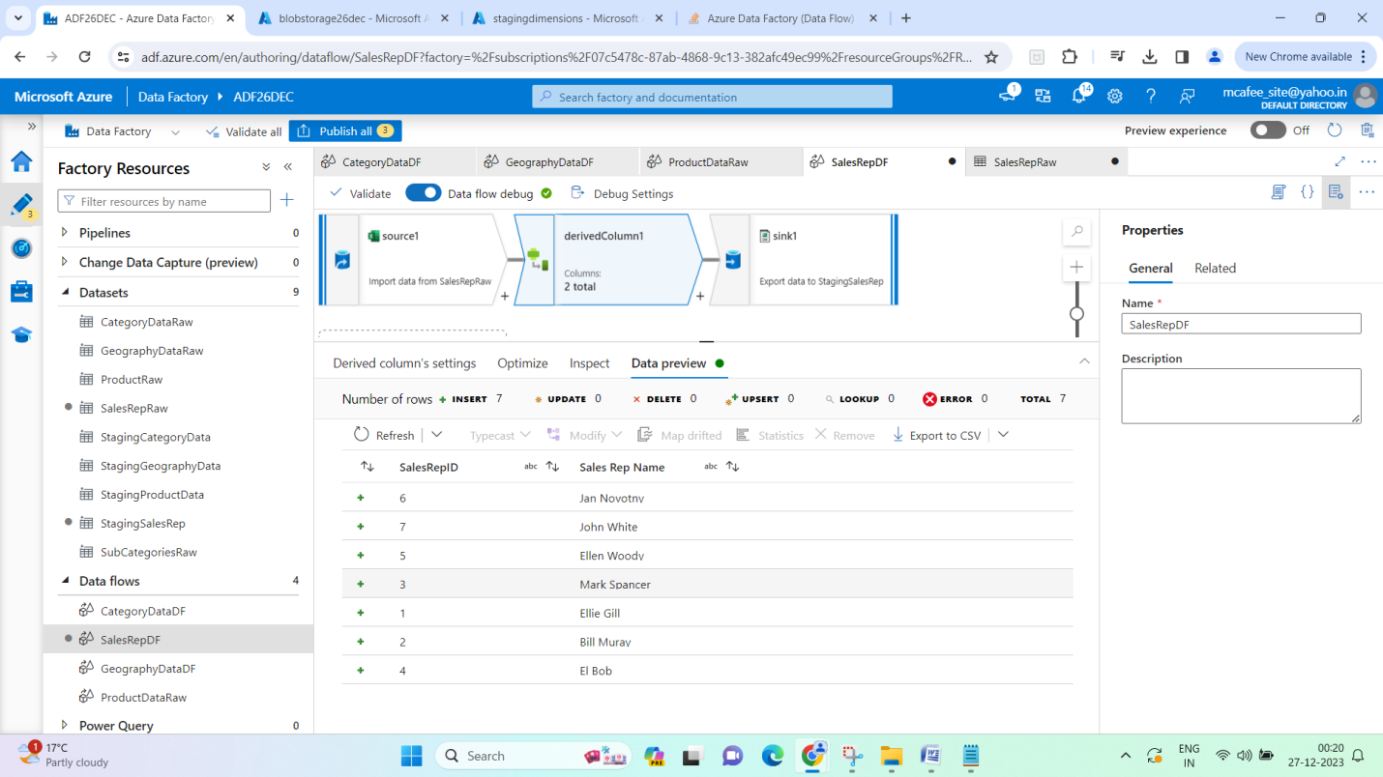

1. SubCategory dimension dataflow -

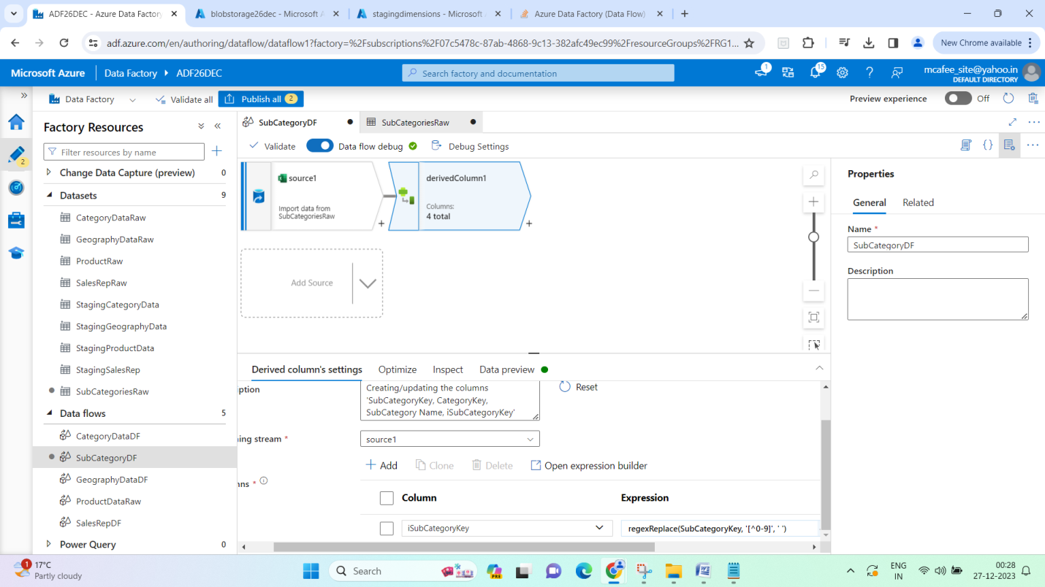

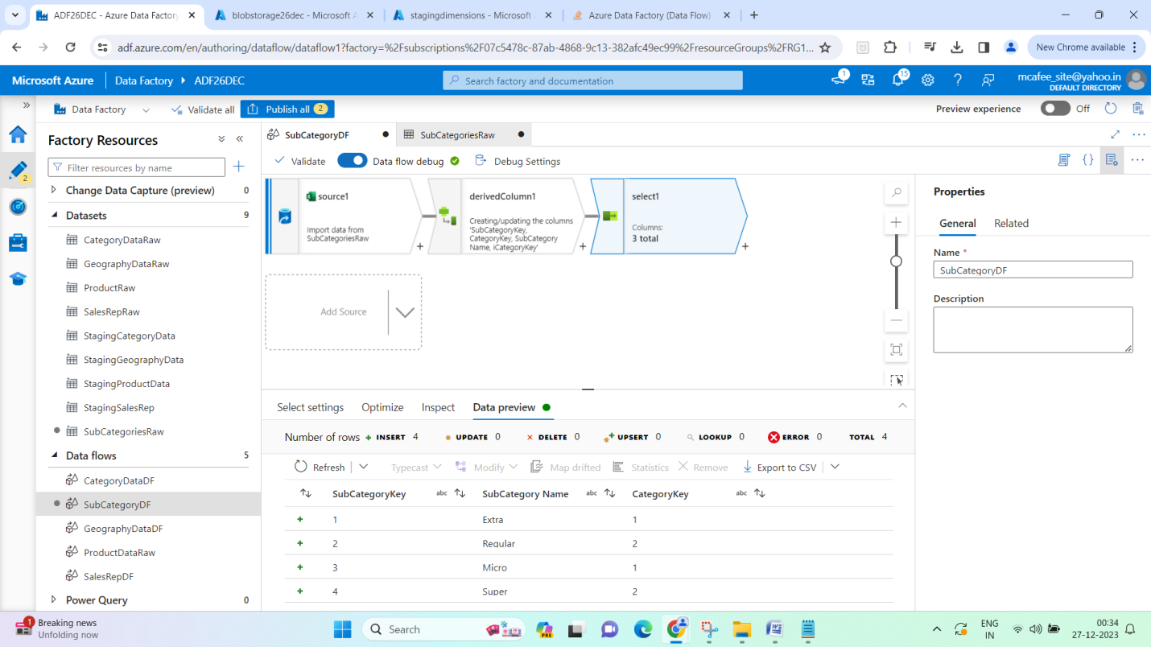

1. Publish 5 pipelines –

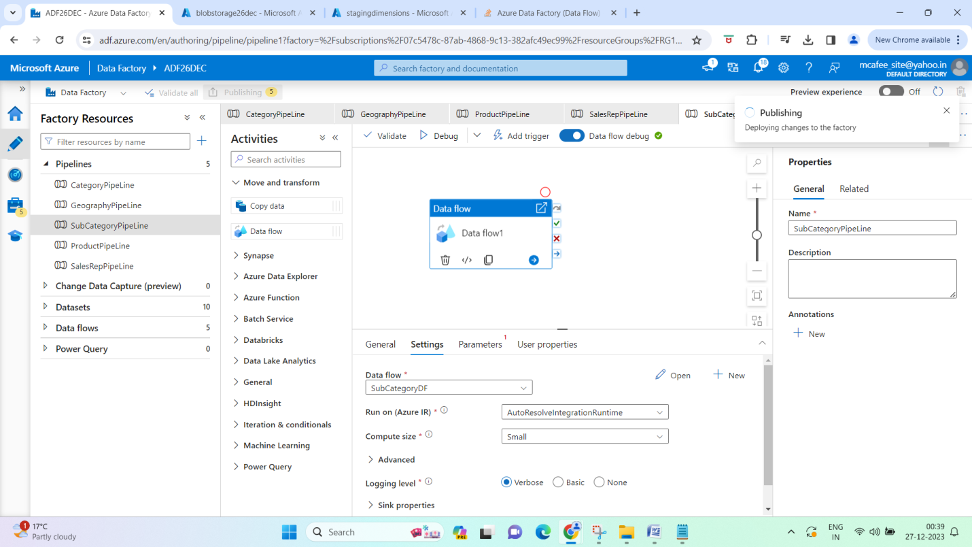

1. Run main pipeline (it has execute pipeline function on all the other 5 pipelines for each dimension) –

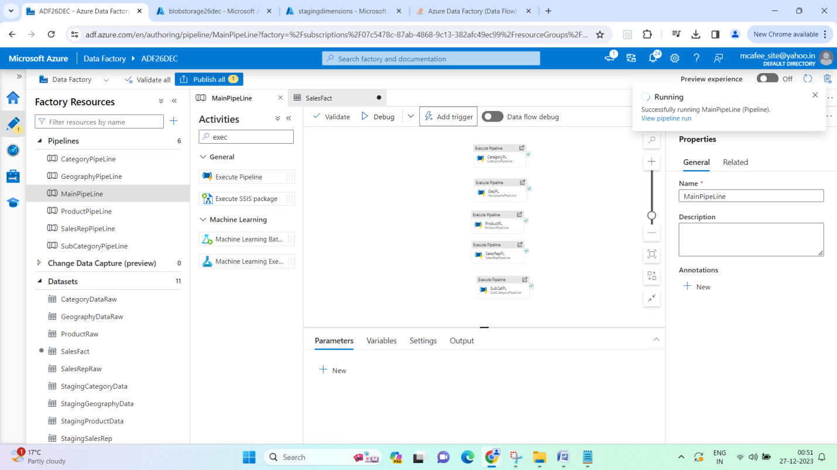

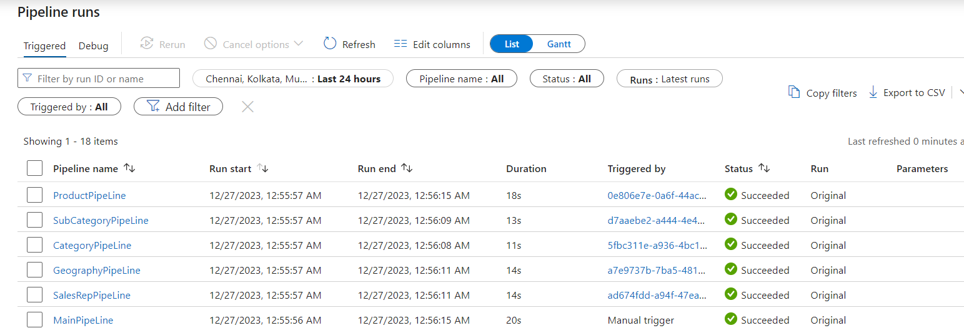

1. Uneven naming convention of files moved to staging folder -

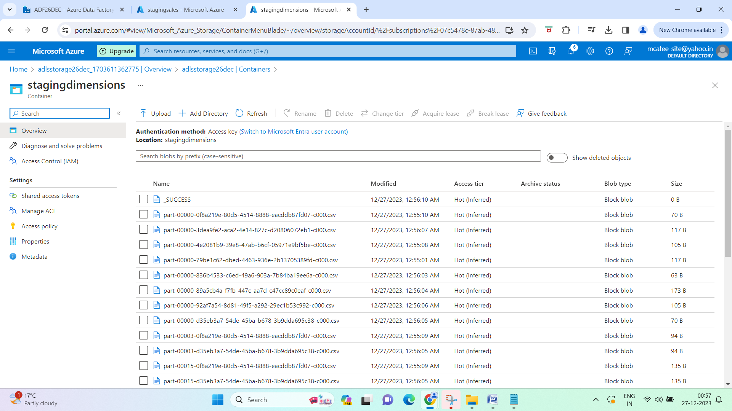

1. Edit dataflows partitioning to 4 – it will create 4 files in staging as shown -

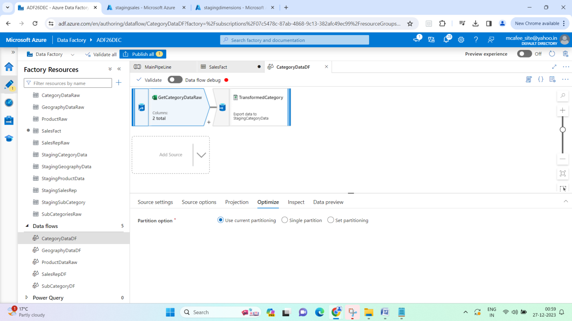

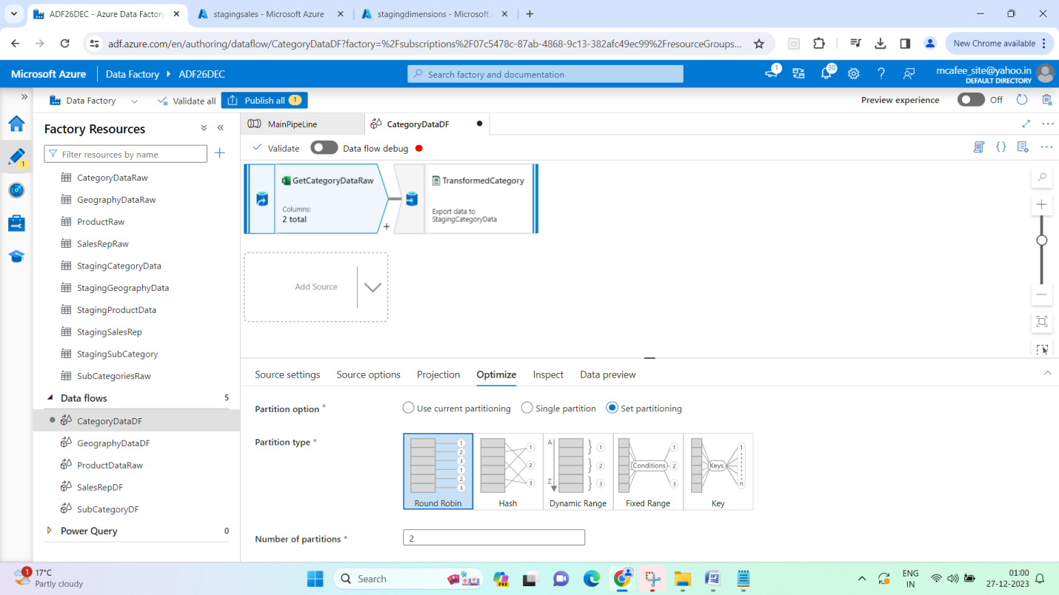

Re-ran after setting partition –

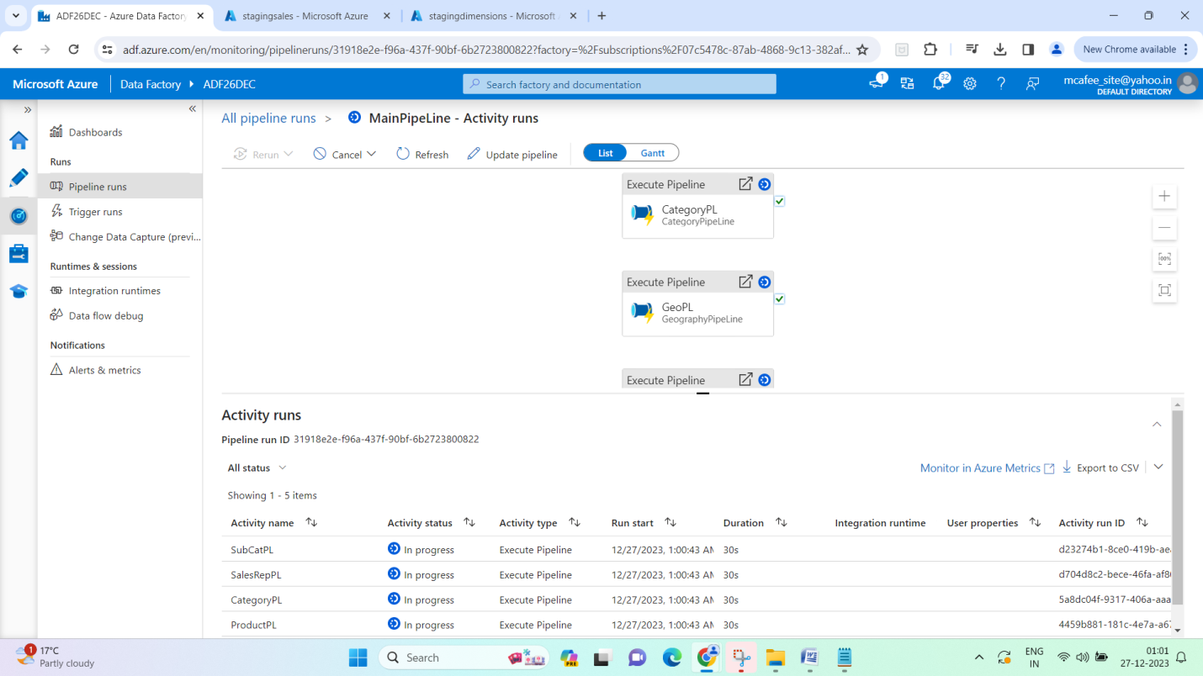

If you have multiple partitions, write operation is faster. If partition = 2 , it will put result in 2 parts/2 files

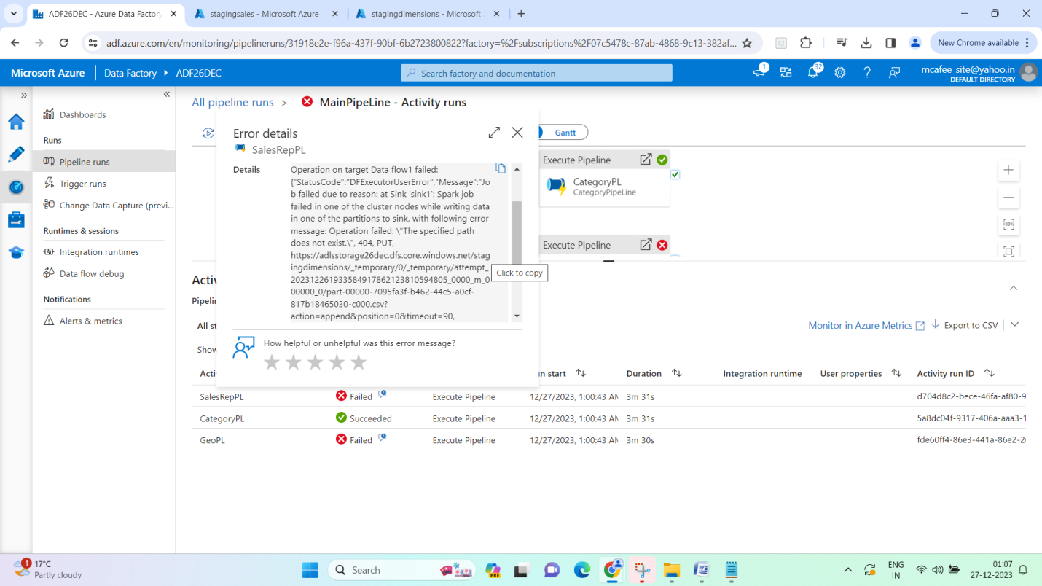

1. For consistent file naming, set the file name option – Pattern and specify a pattern -

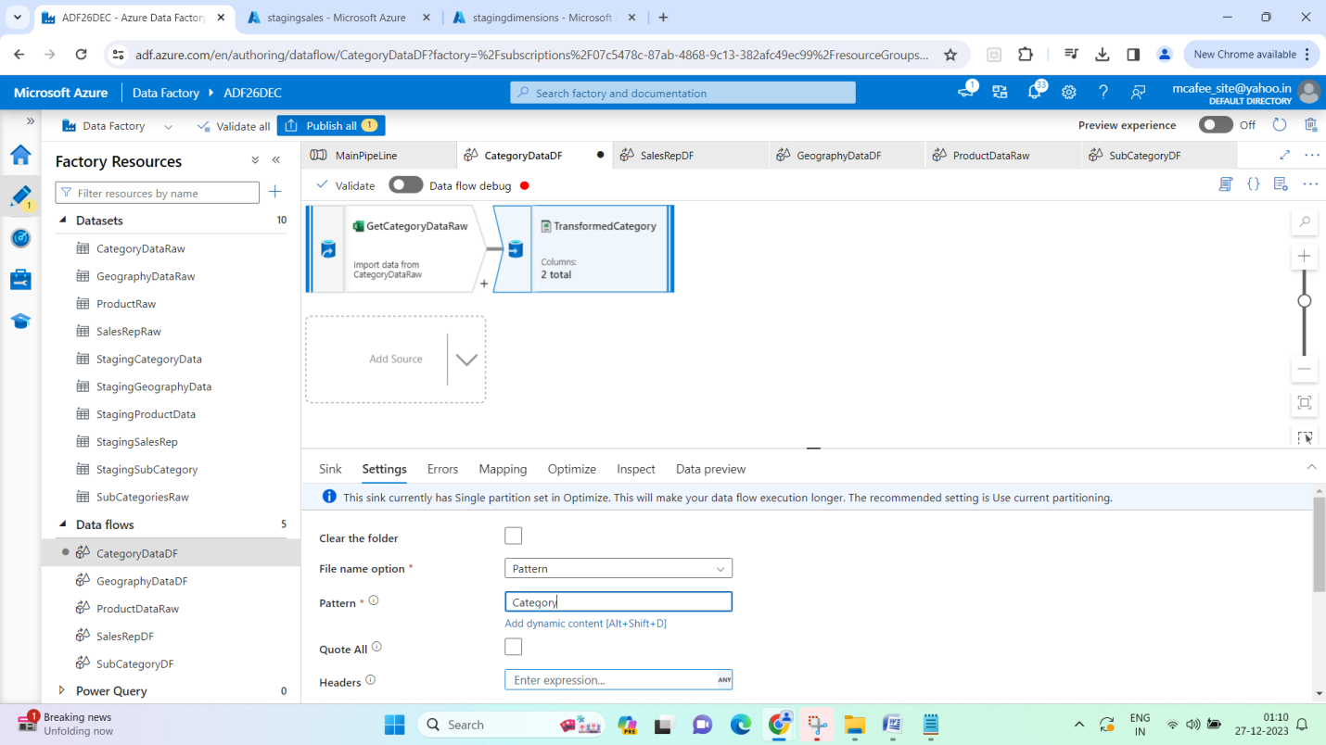

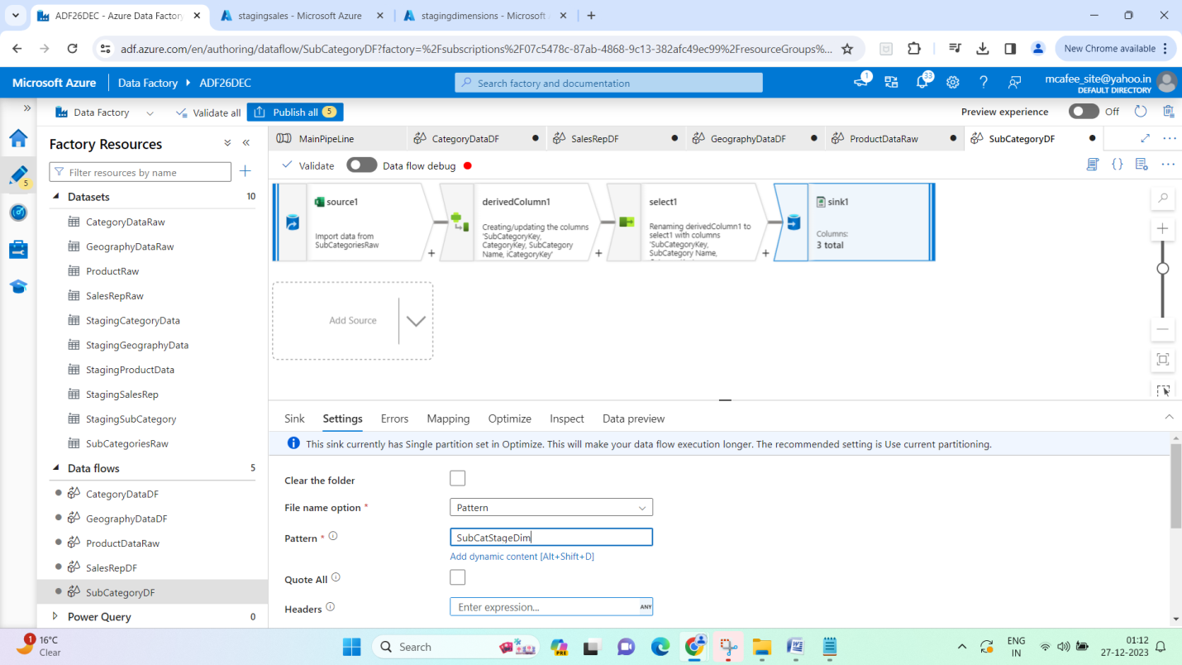

1. Re-run pipeline –

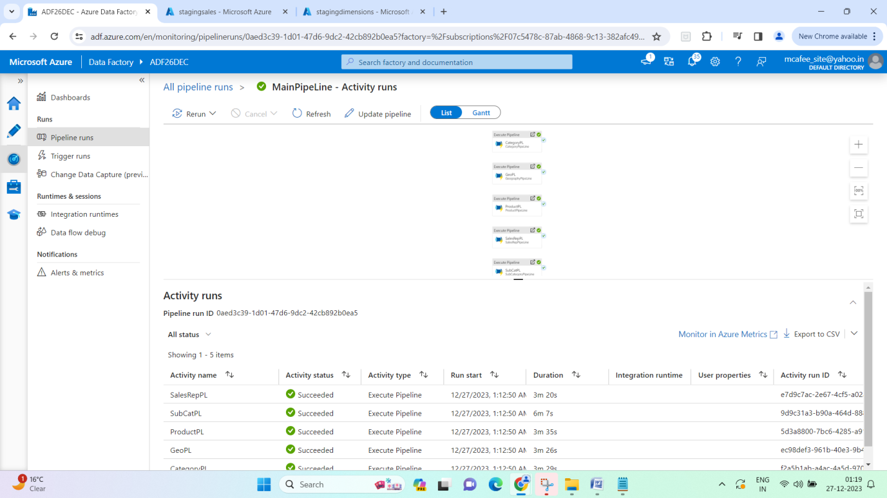

1. Now, create dataset and dataflow for Sales fact table

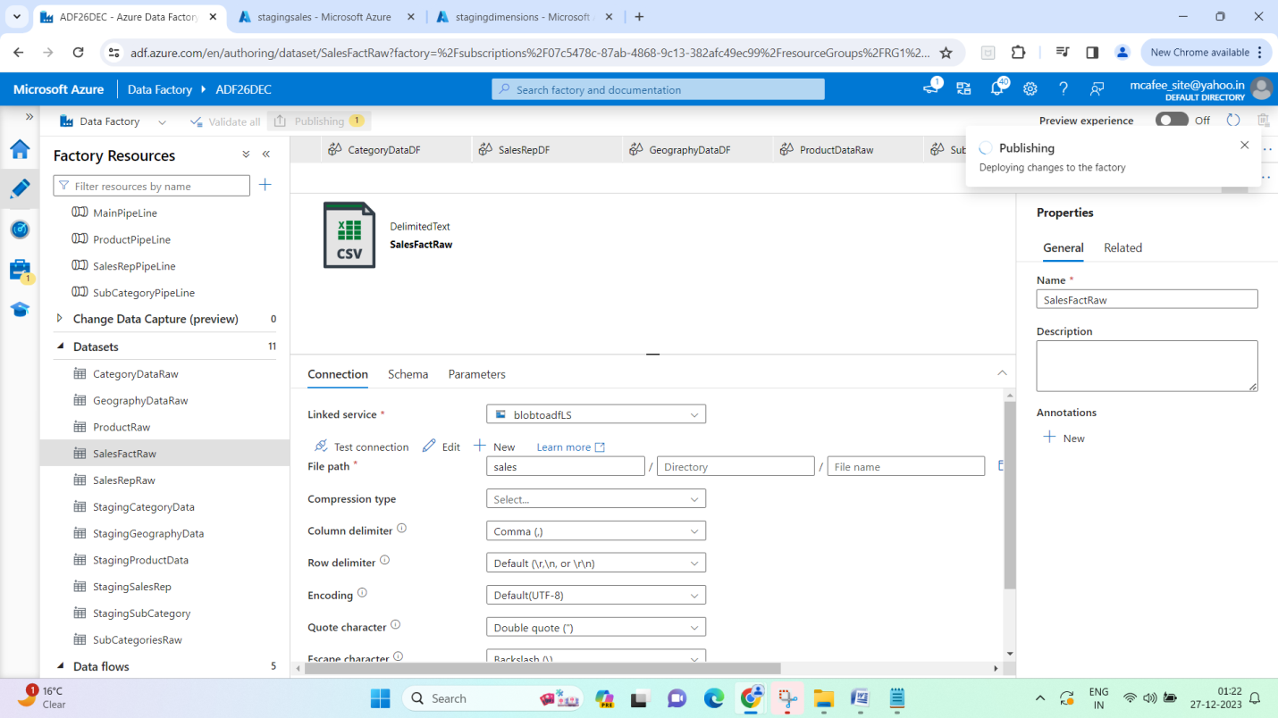

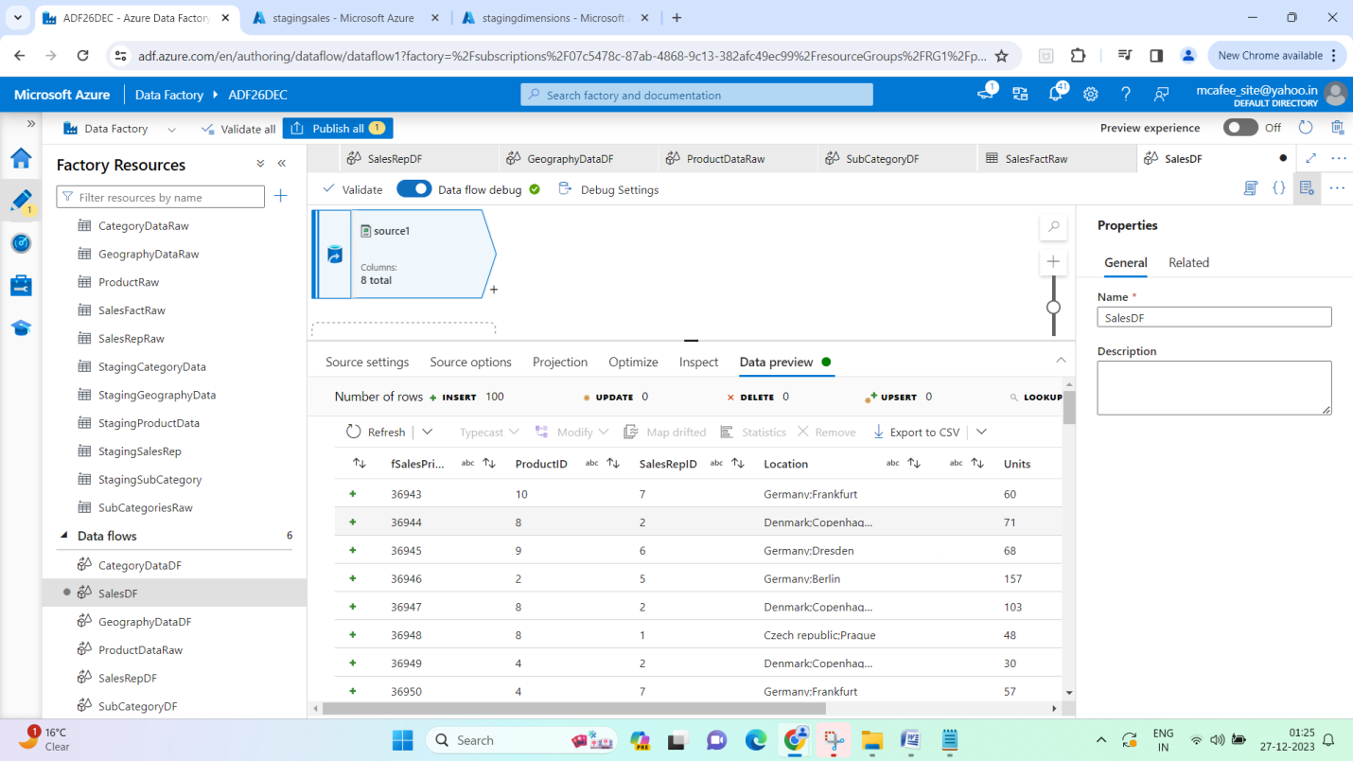

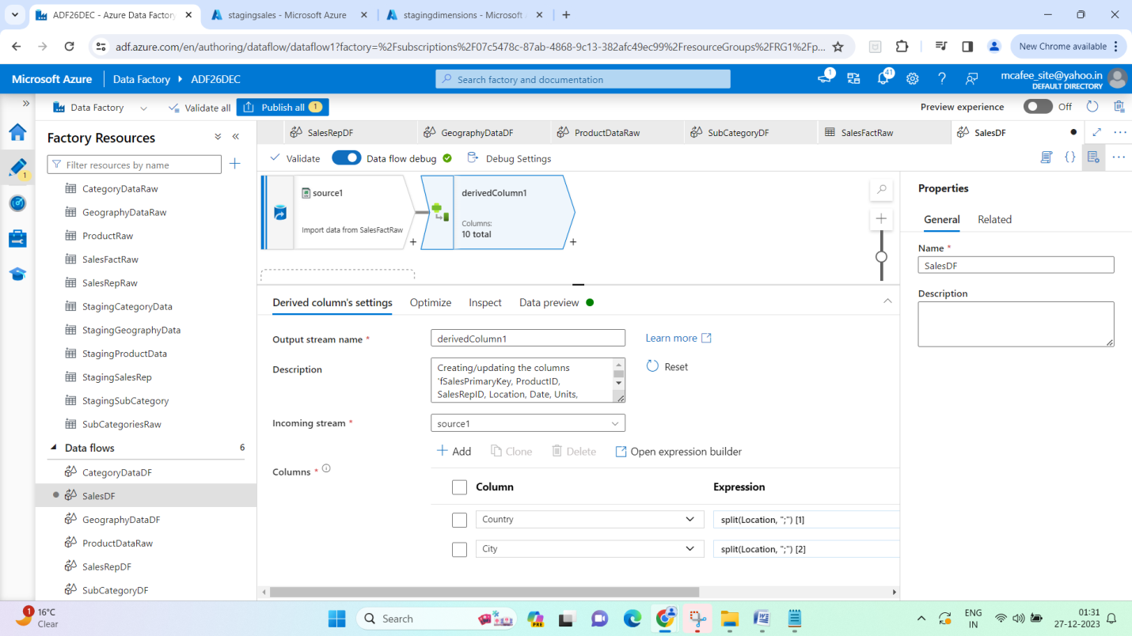

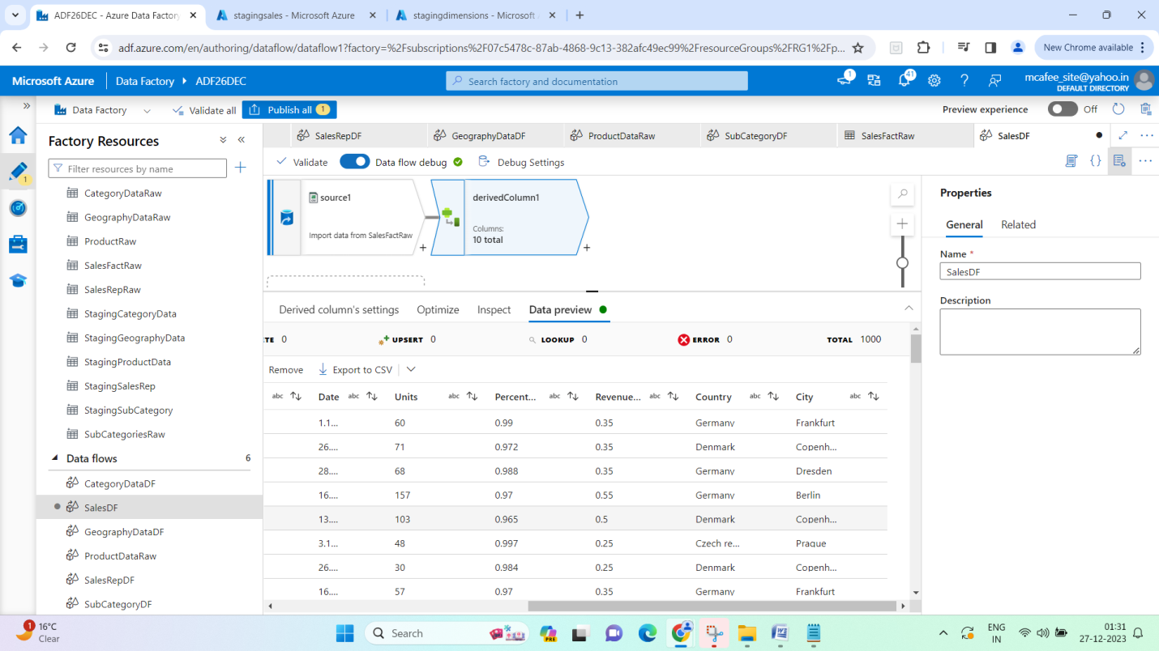

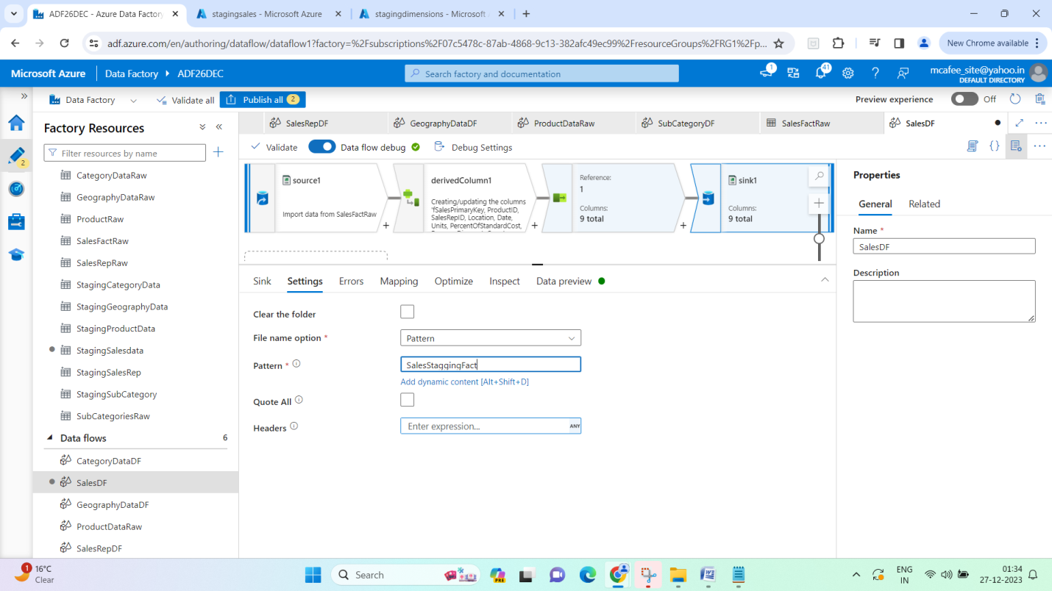

1. Ran sales pipeline alone to see if it executes successfully –

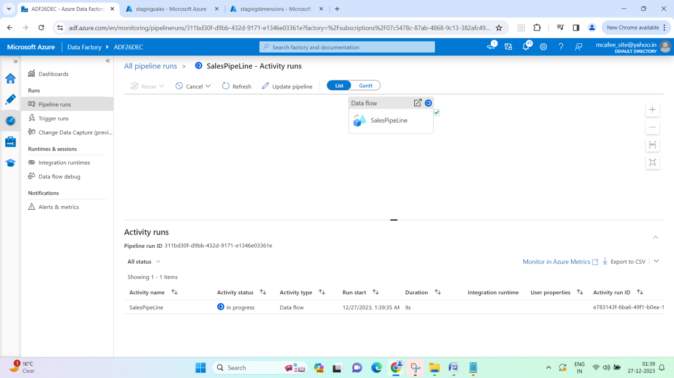

All 4 files in sales get merged to one single file –

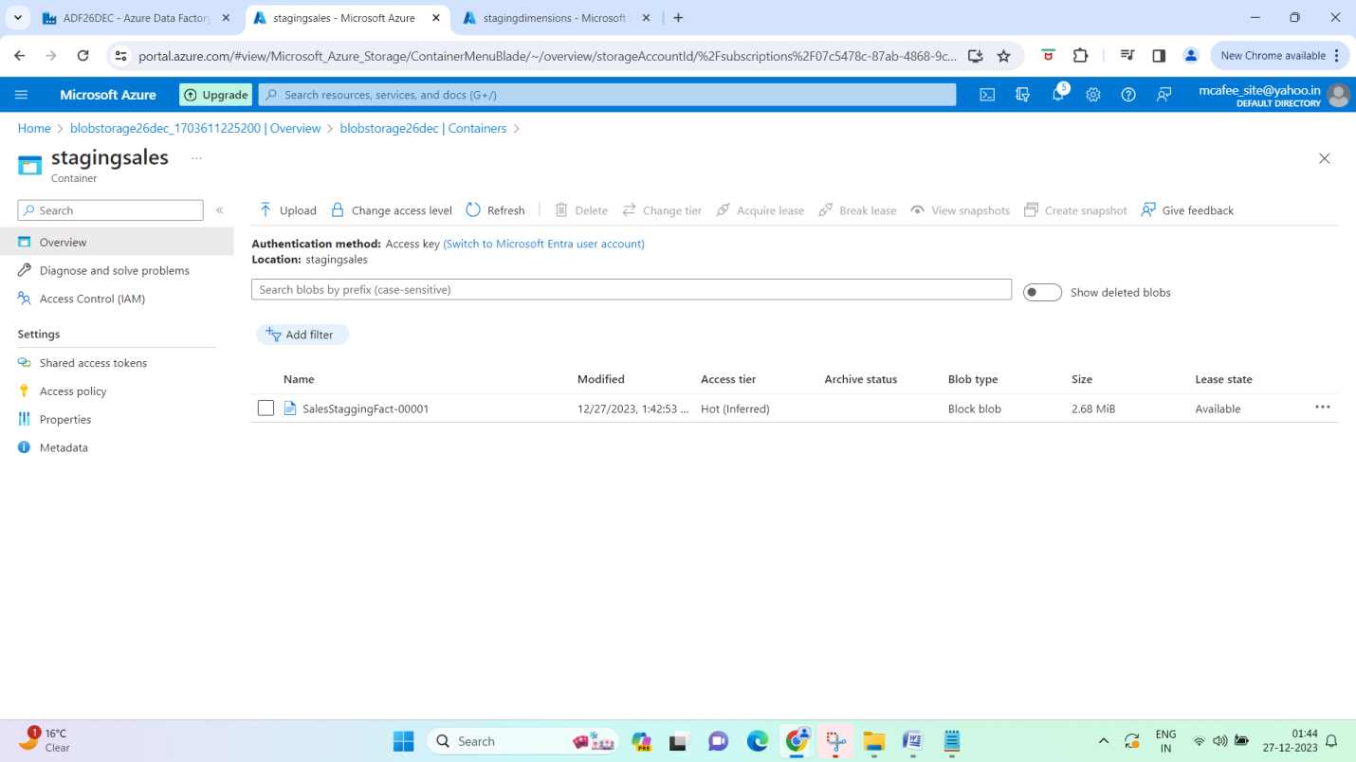

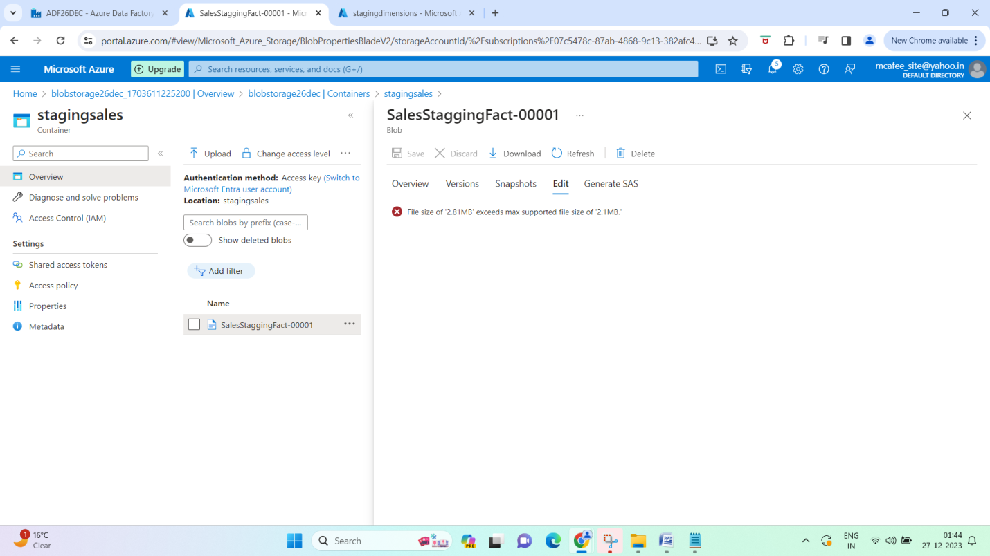

You can download to check it out

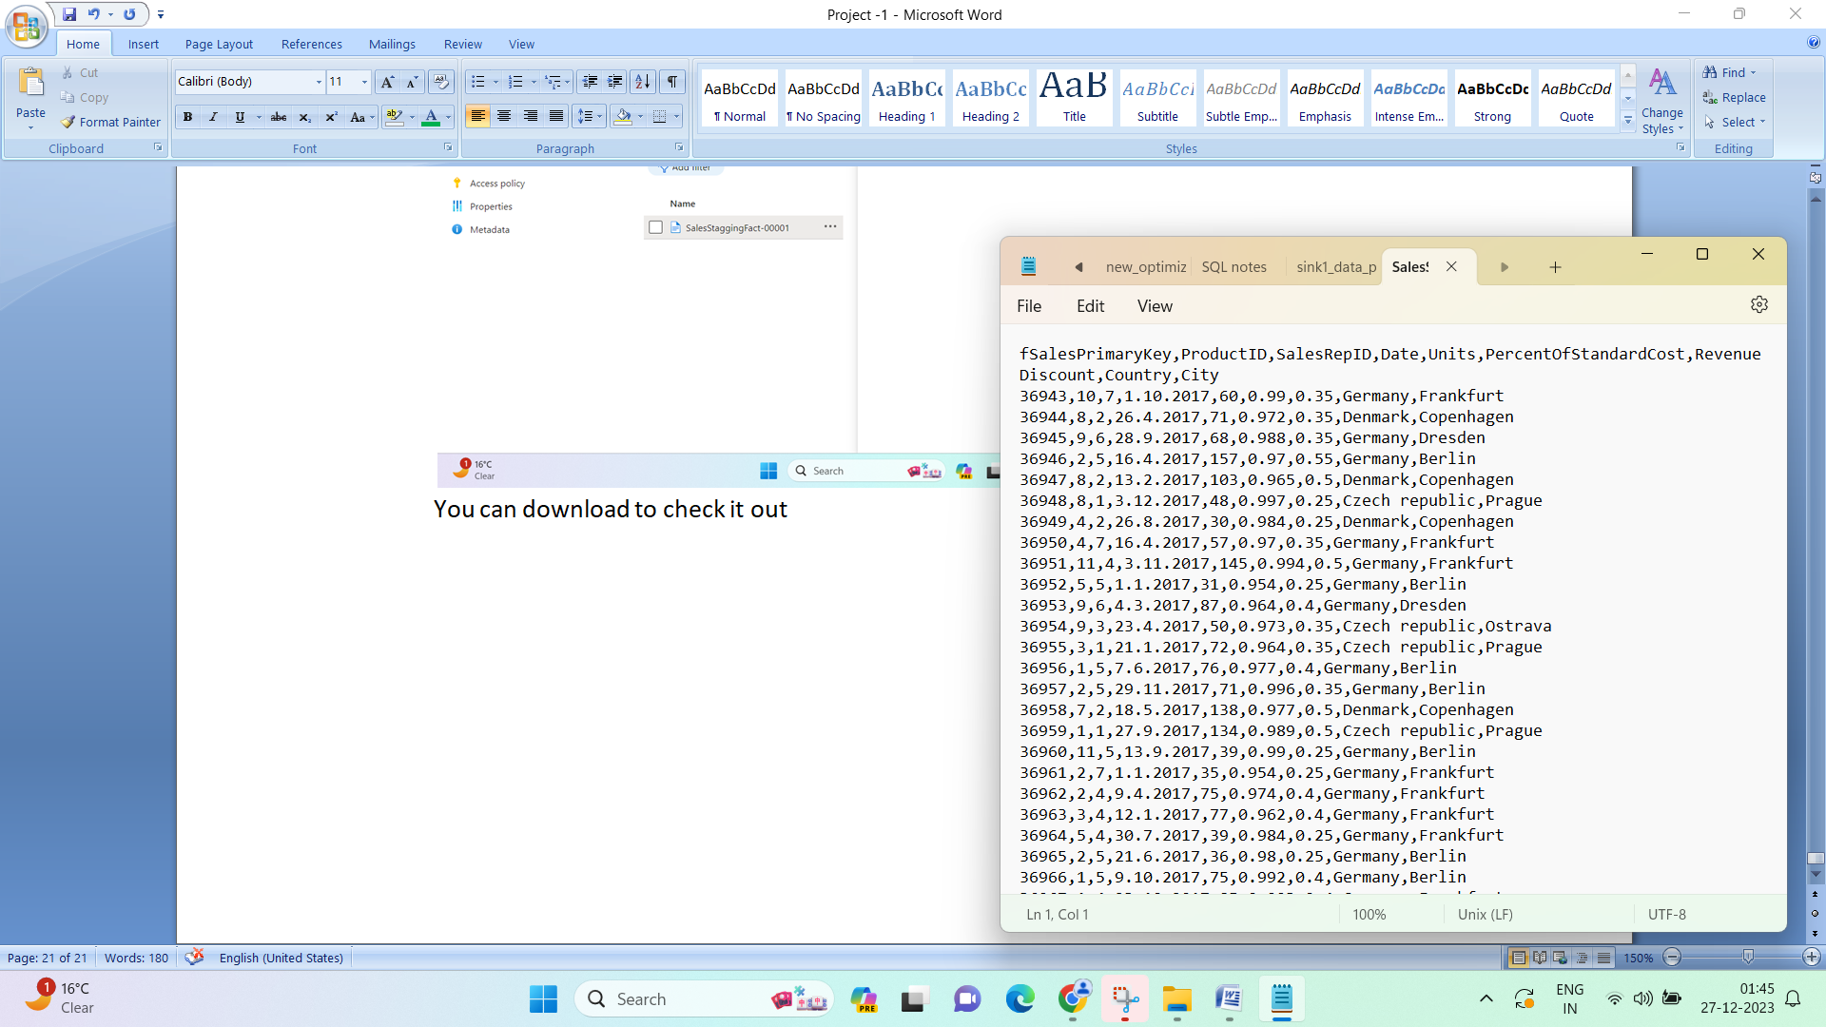

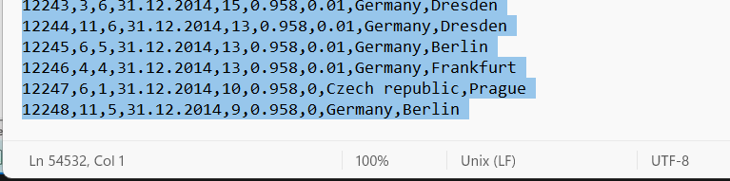

Note the number of columns – 54532

1. Add the execute pipeline for Sales -

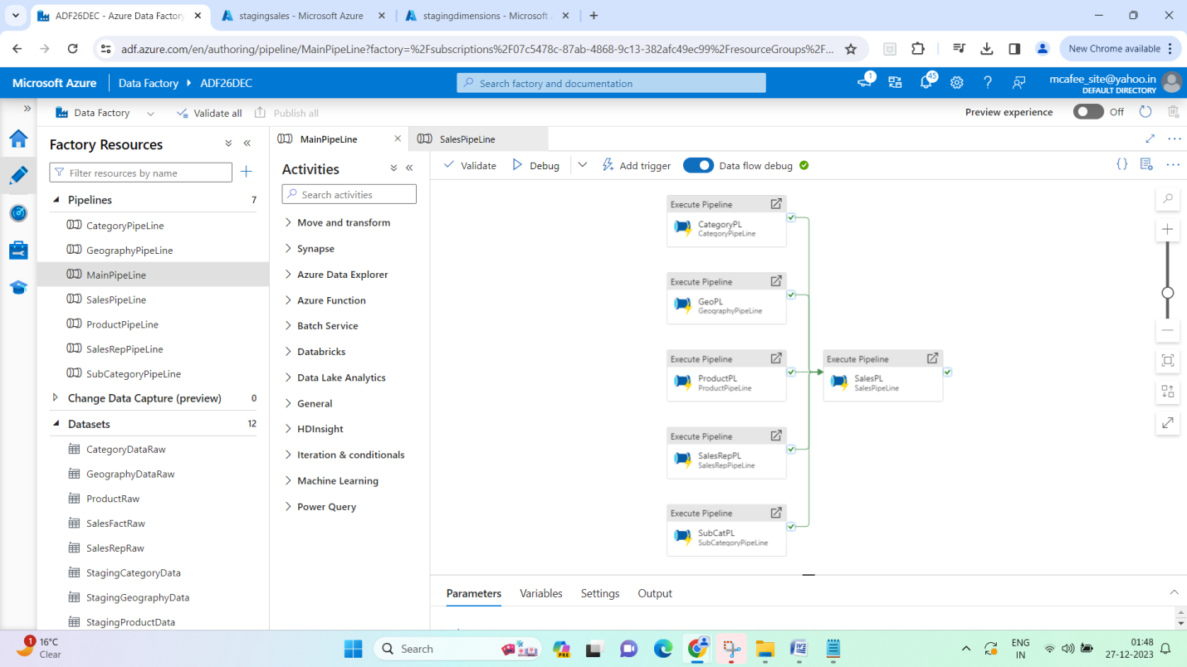

1. Trigger the full pipeline.

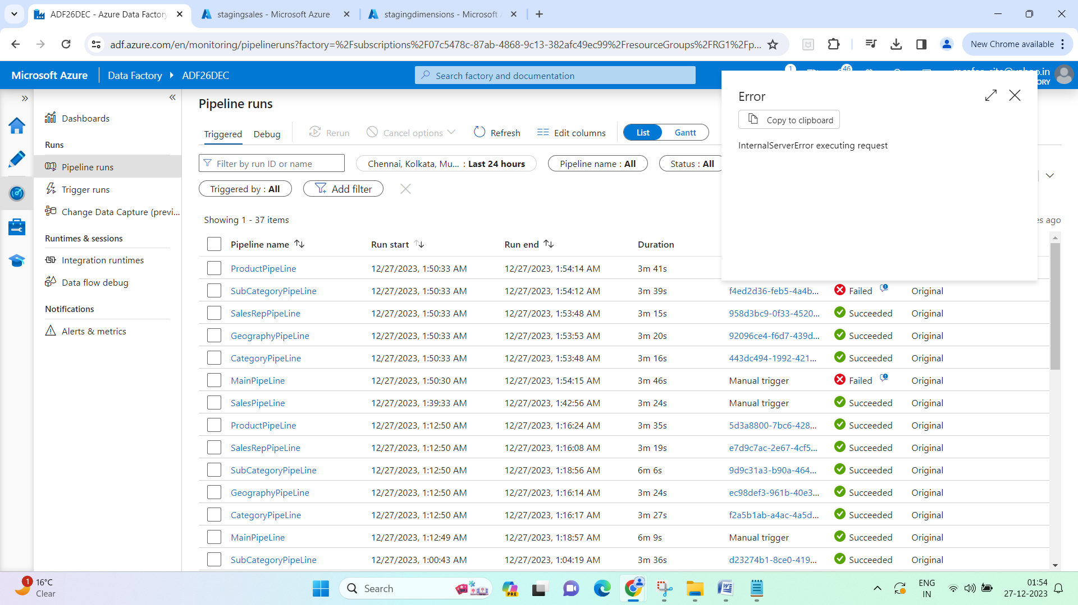

1. RE-ran subcategory alone, it worked fine, re-ran full pipeline again

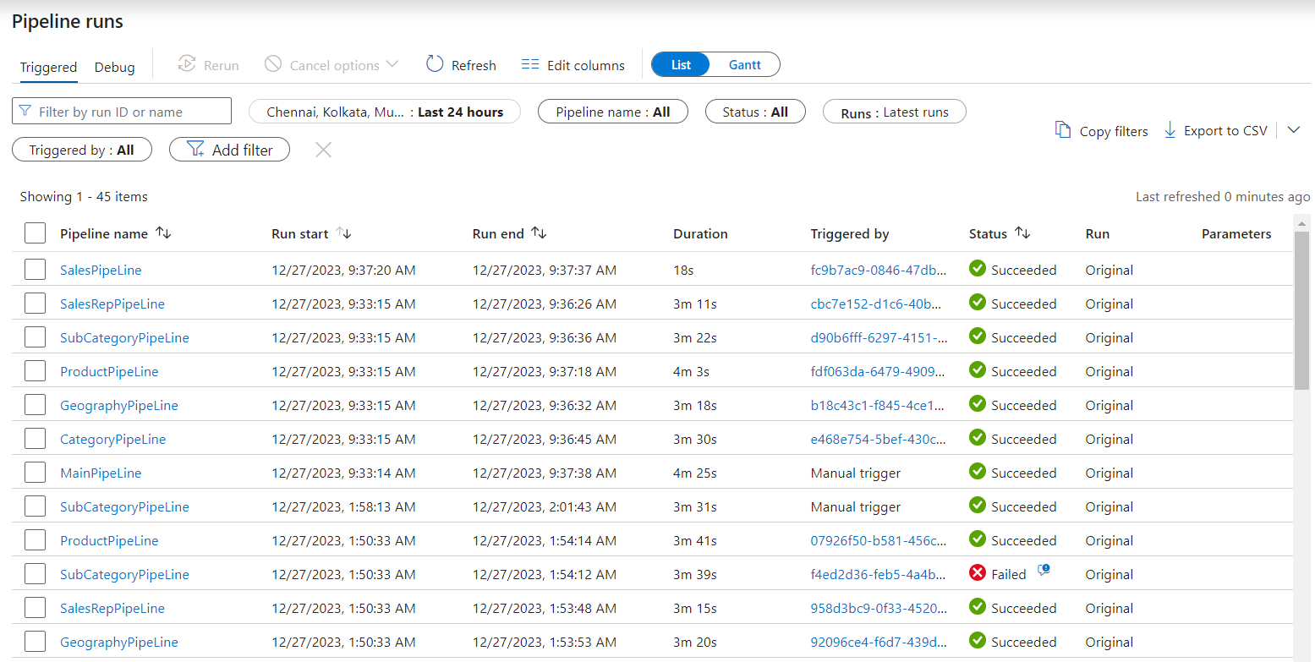

1. Check the staging folder for dimensions in adls

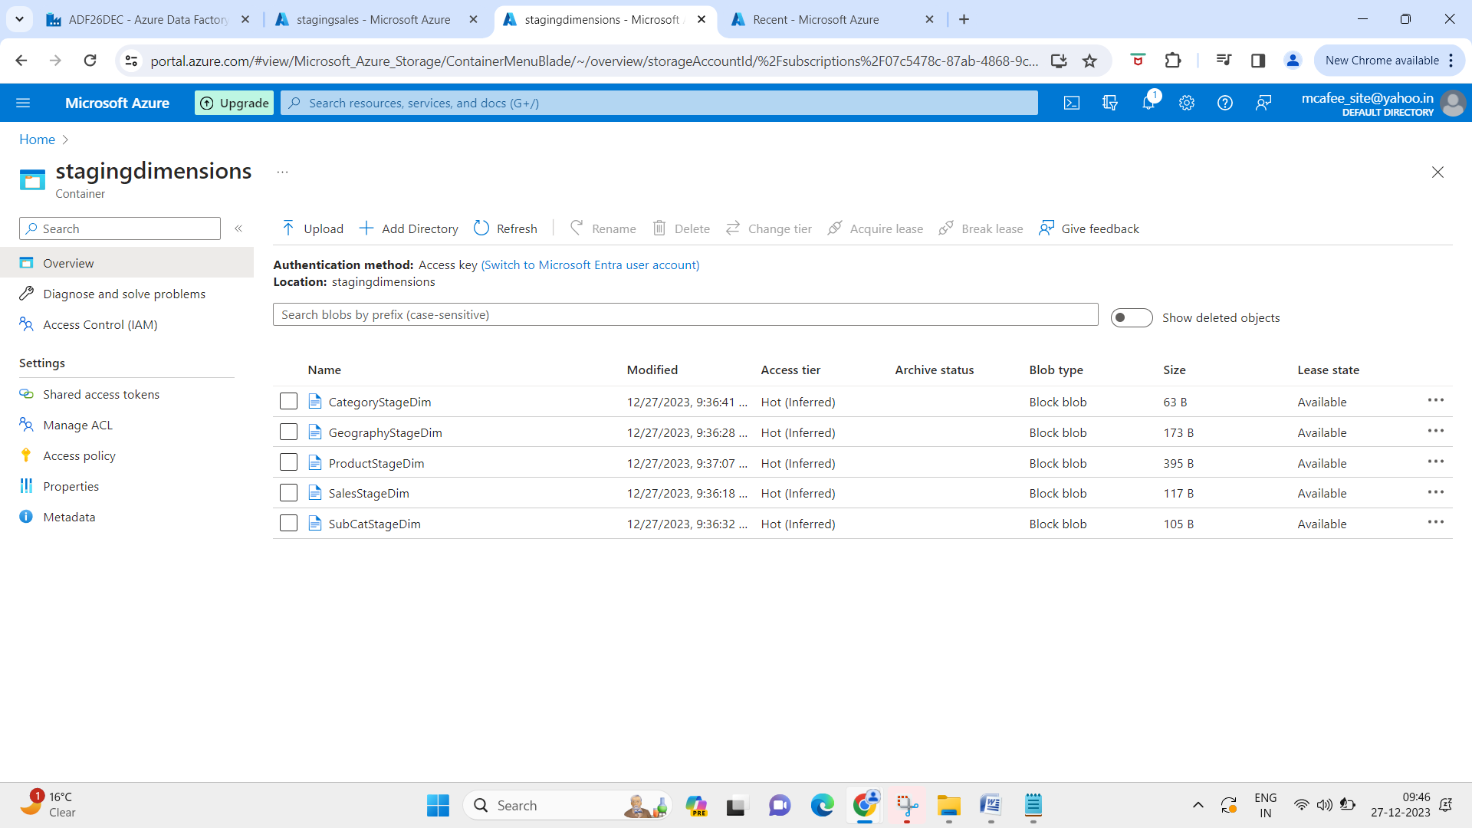

1. Check blob staging folder for sales fact

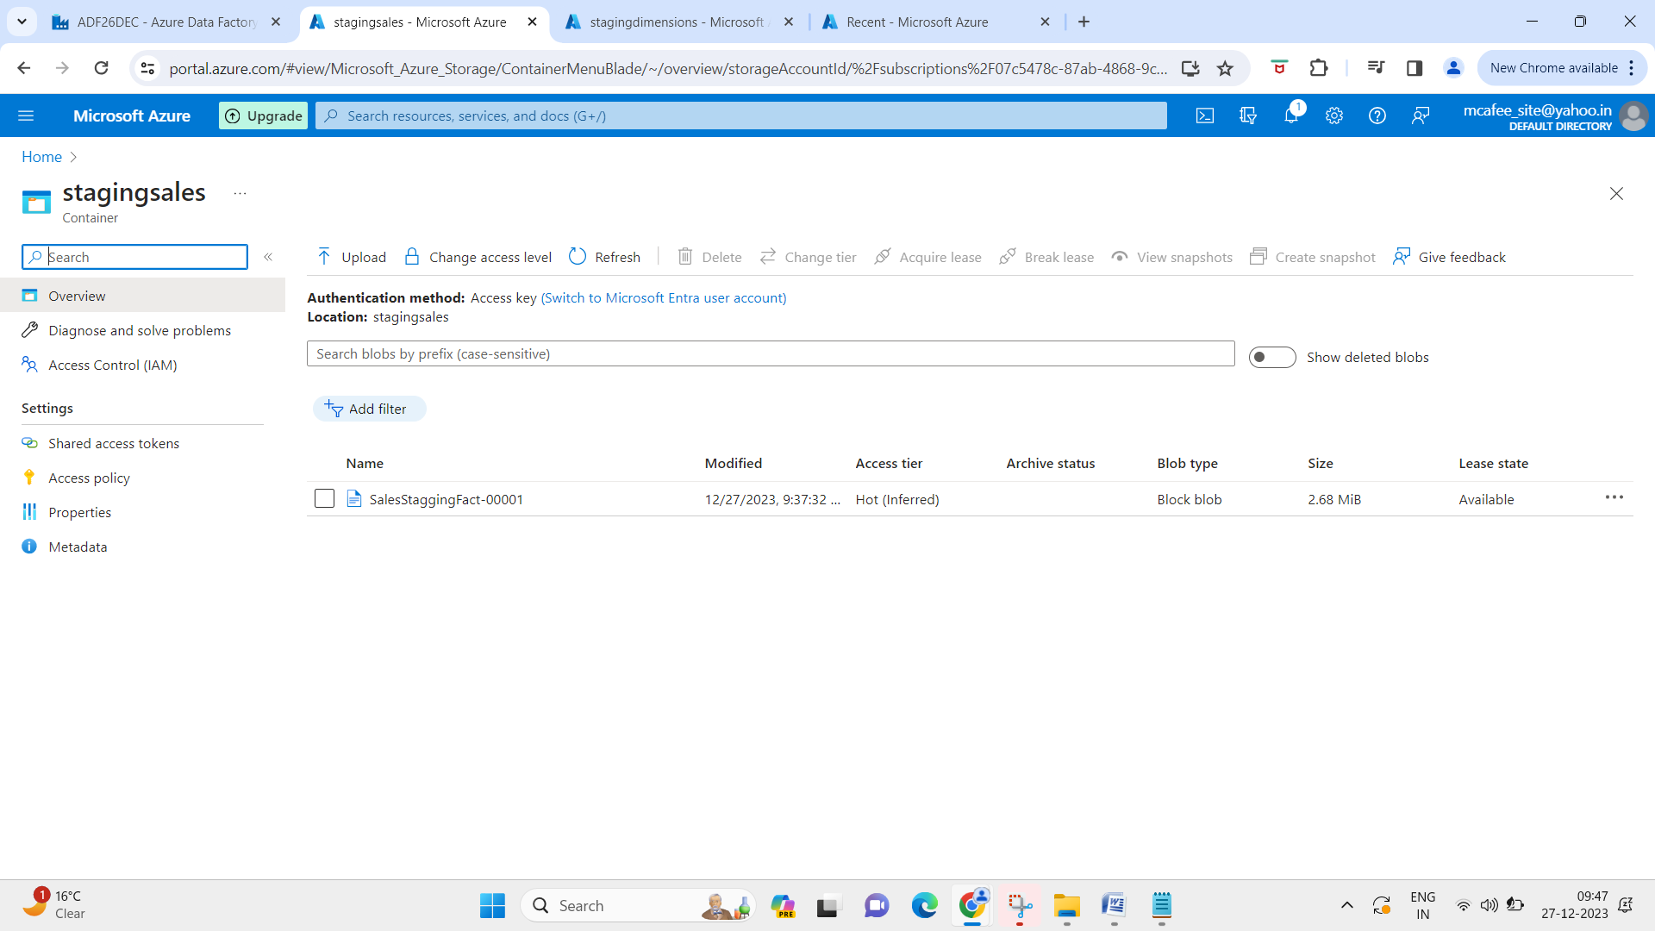

Question – why we load dimension tables first, and then fact data later

* Dimension tables – primary keys, fact tables –has foreign keys
* Fact tables starts looking for IDs in Dimension tables (lookup tables – this has all the data)

1. Improving this pipeline (optional) –

Create an azure logic app notification for each pipeline – for success and failure email – did not create or capture to reserve credits for other practice

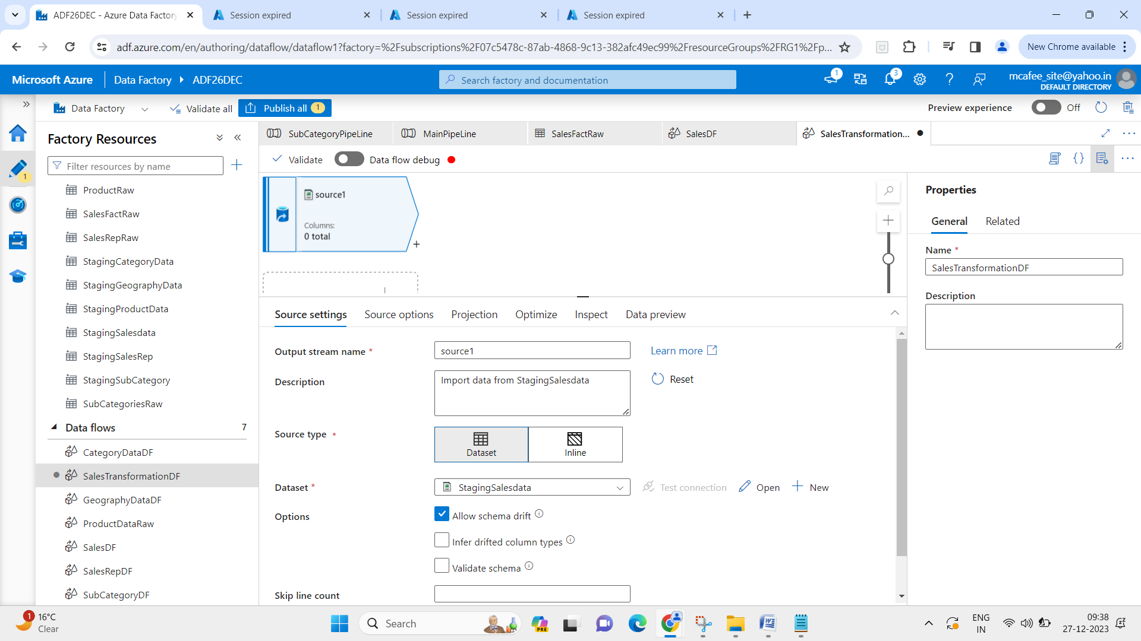

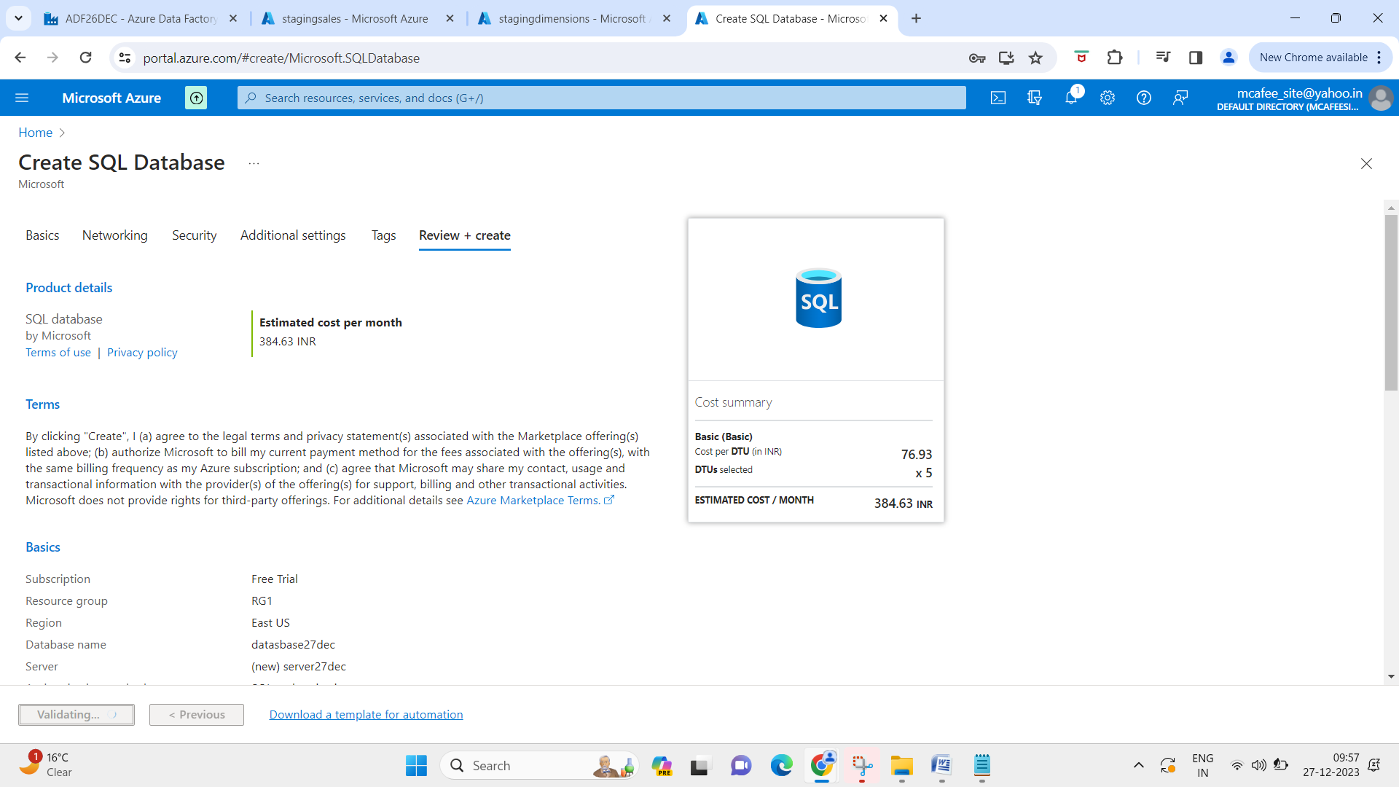

1. Create sales transformation dataflow - If it shows zero total columns, import schema as follows –

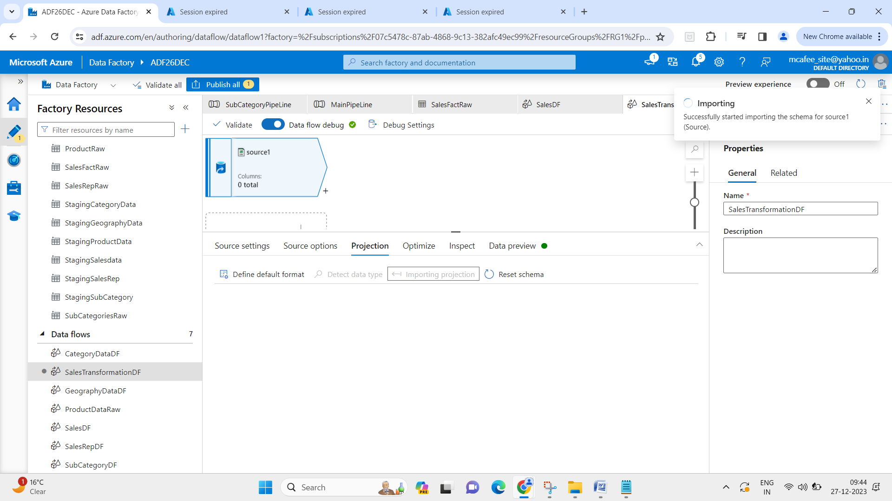

Get fact sales data from staging -

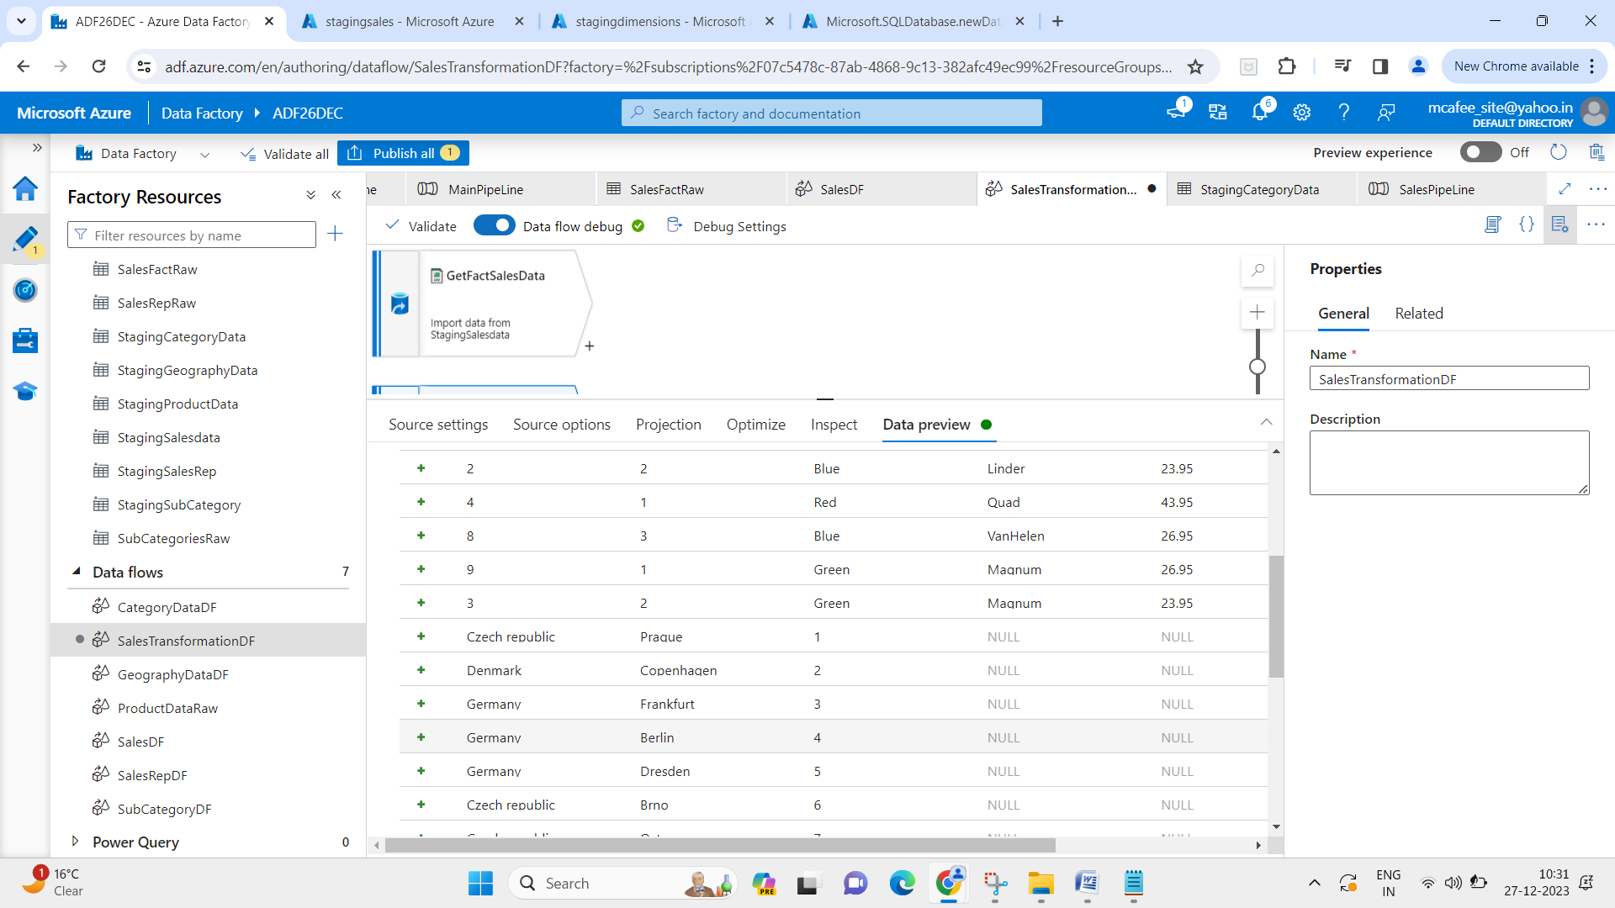

Issue – In staging Product data dataset, I have selected just staging folder due to which all the data in staging folder is getting clubbed on this preview.

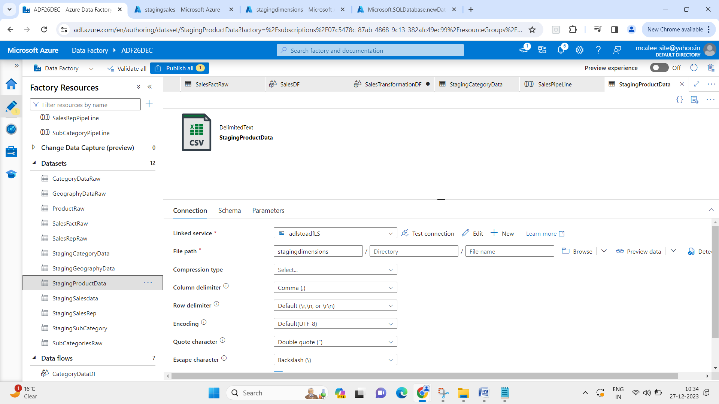

1. To resolve, select the exact file name on file path –

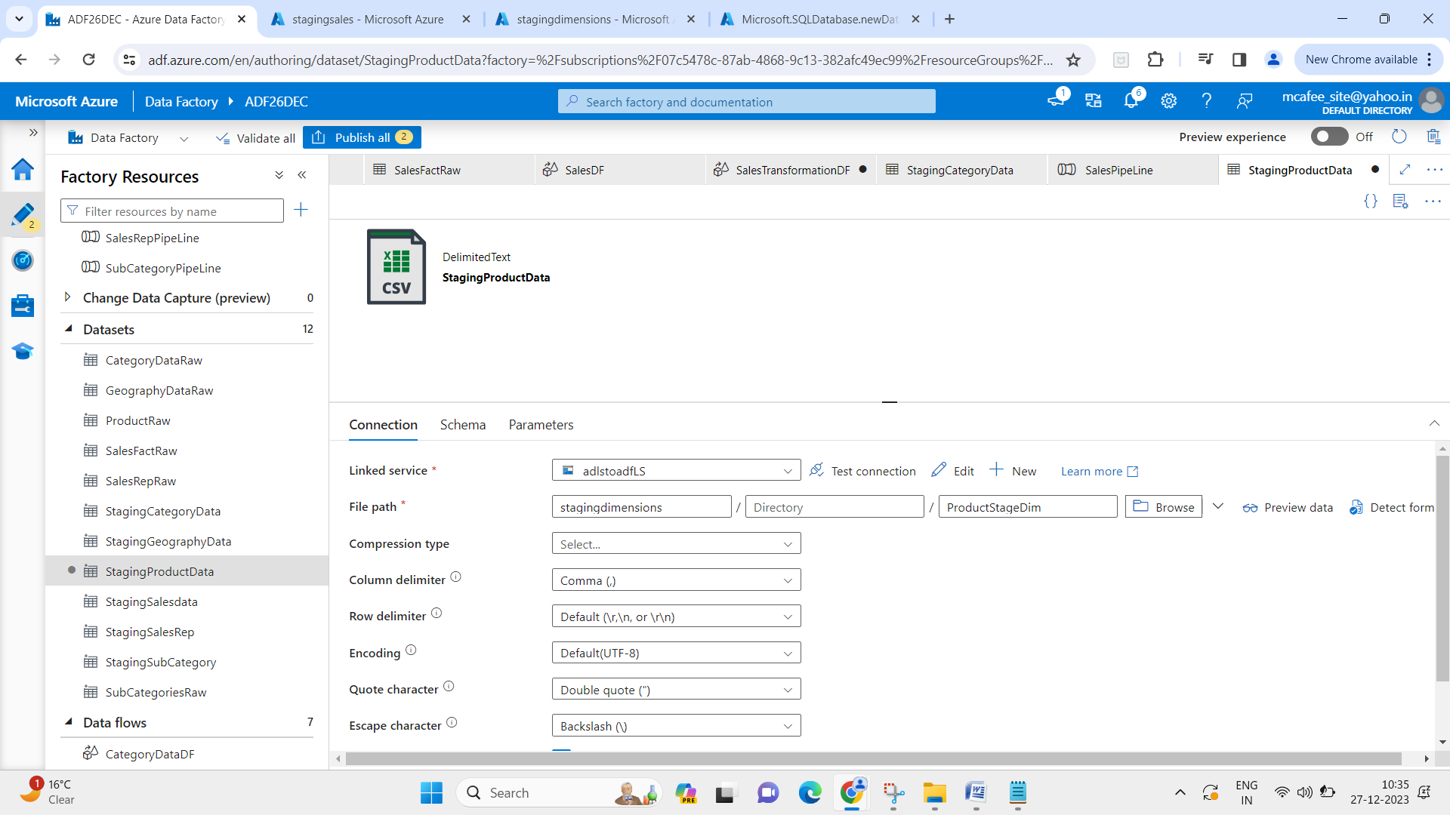

1. Get product data from staging, join with fact sales data from staging -- output on 1

then get product data and join with output on 1

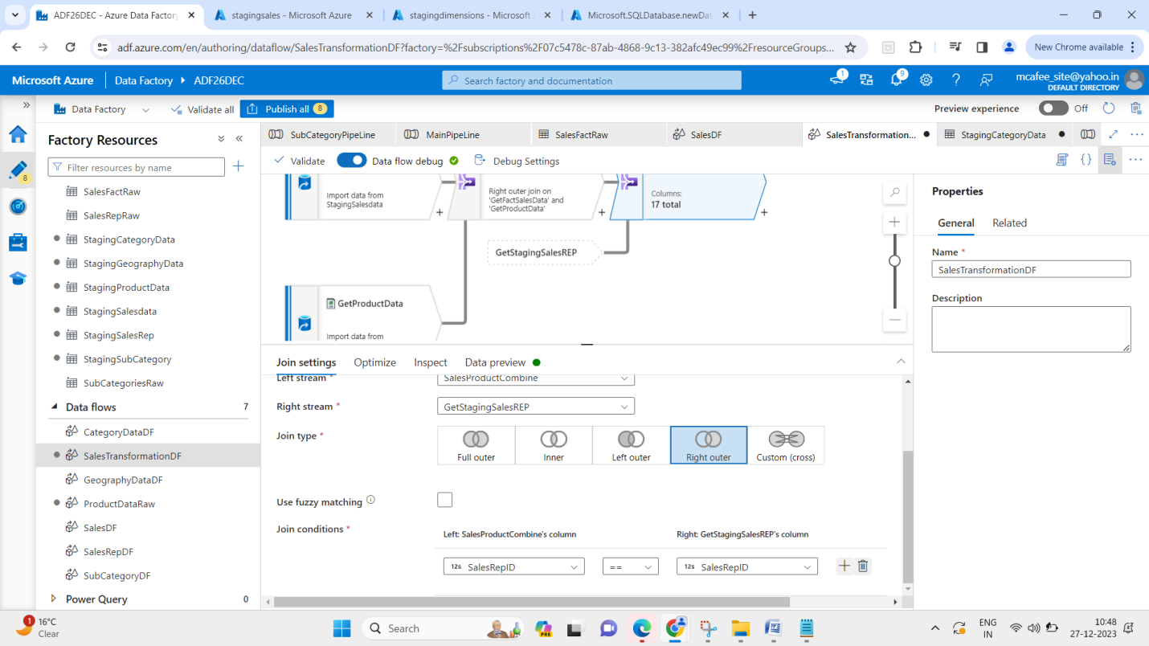

1. Get staging subcategory data and category data and join

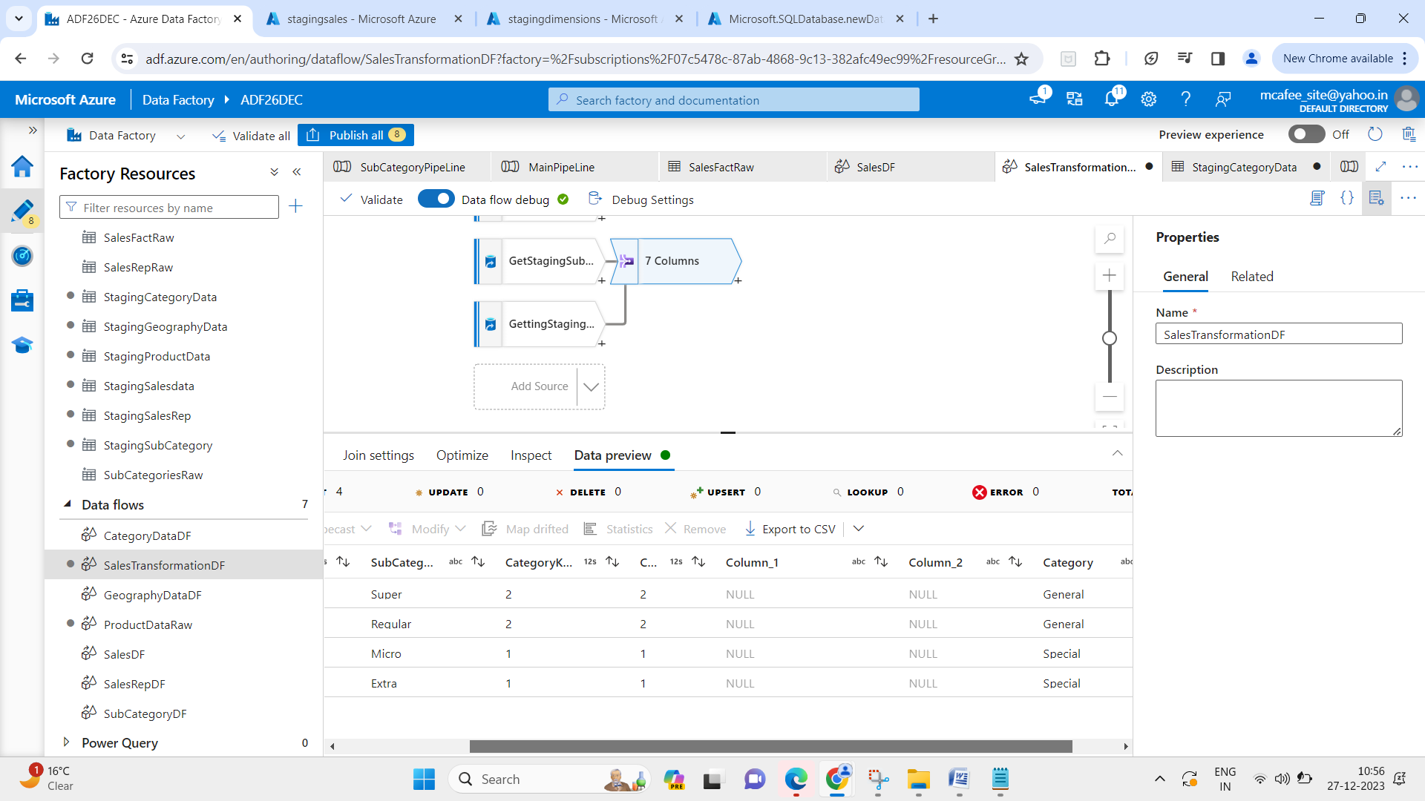

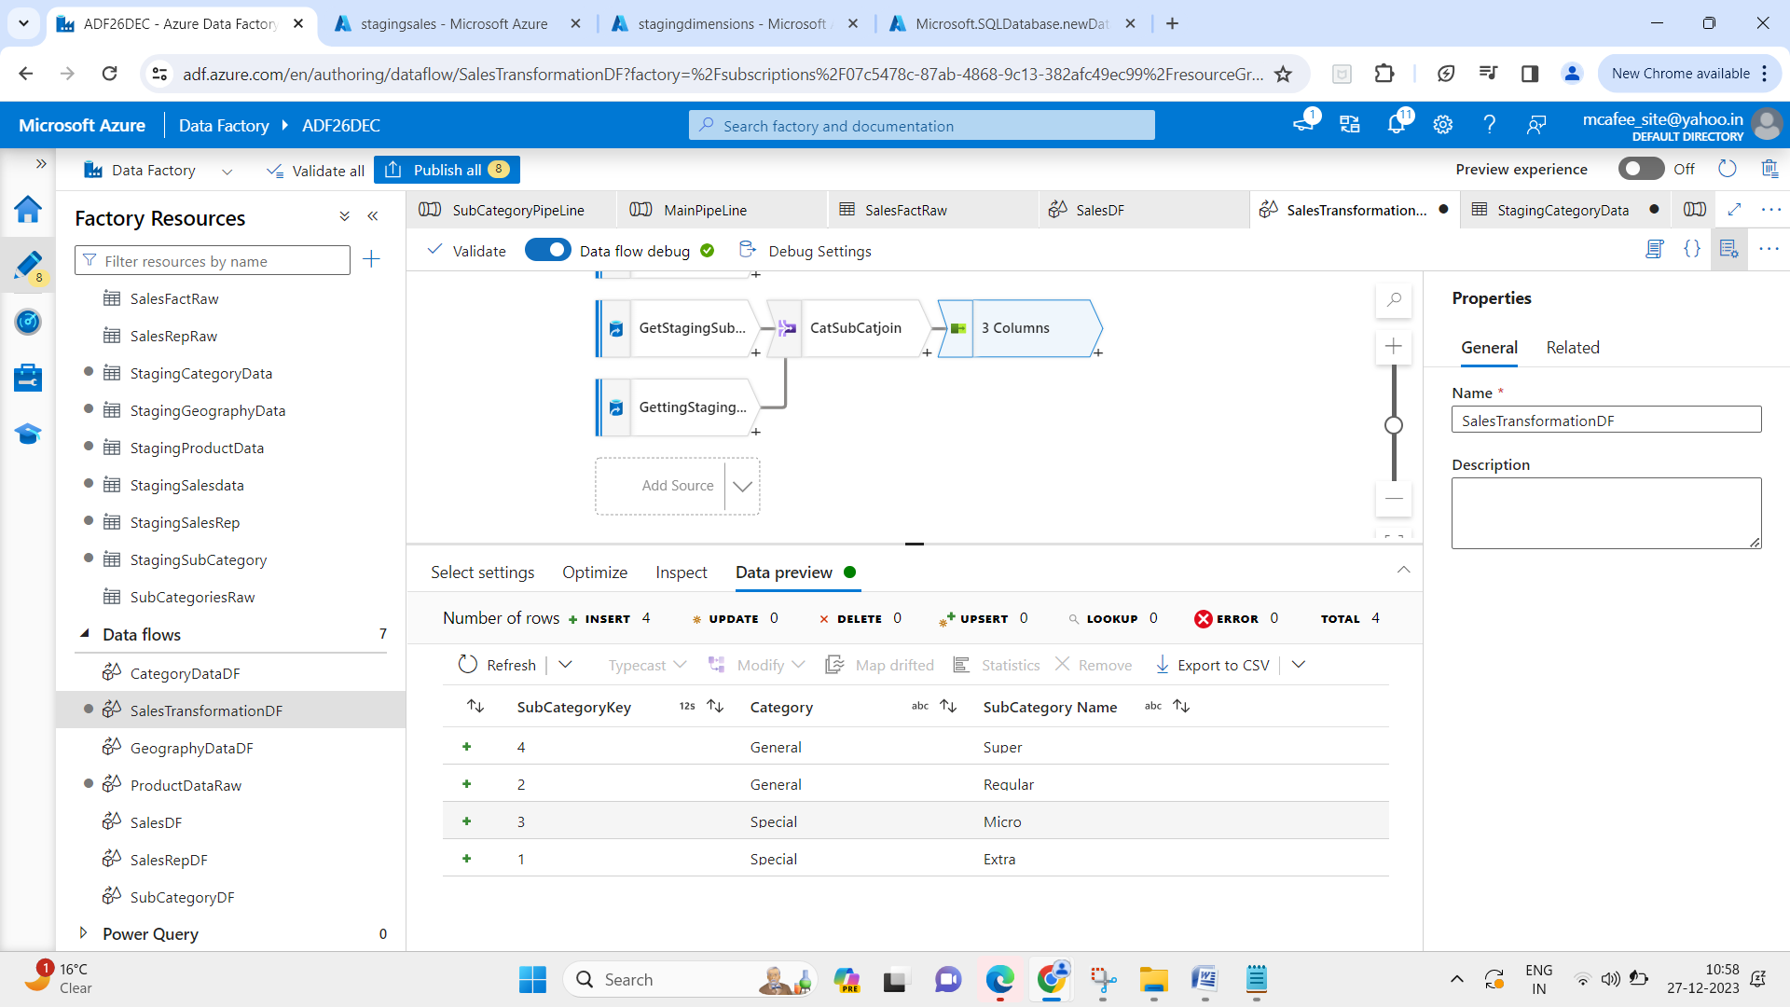

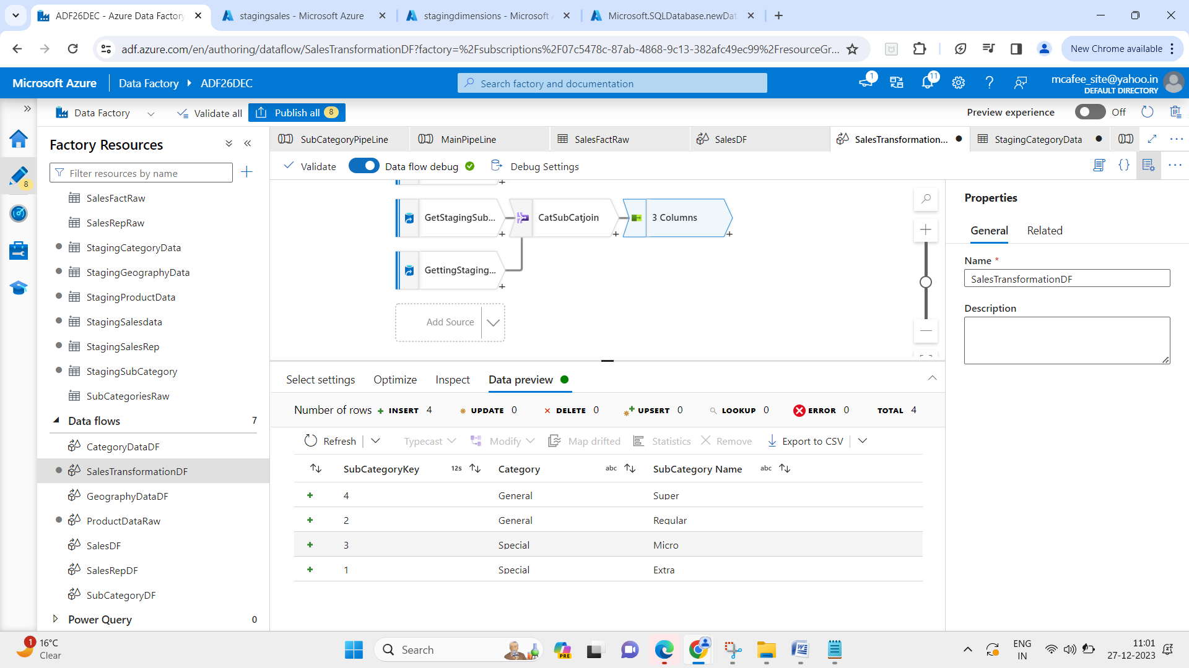

1. Join salesproduct join with – catsubcategory join

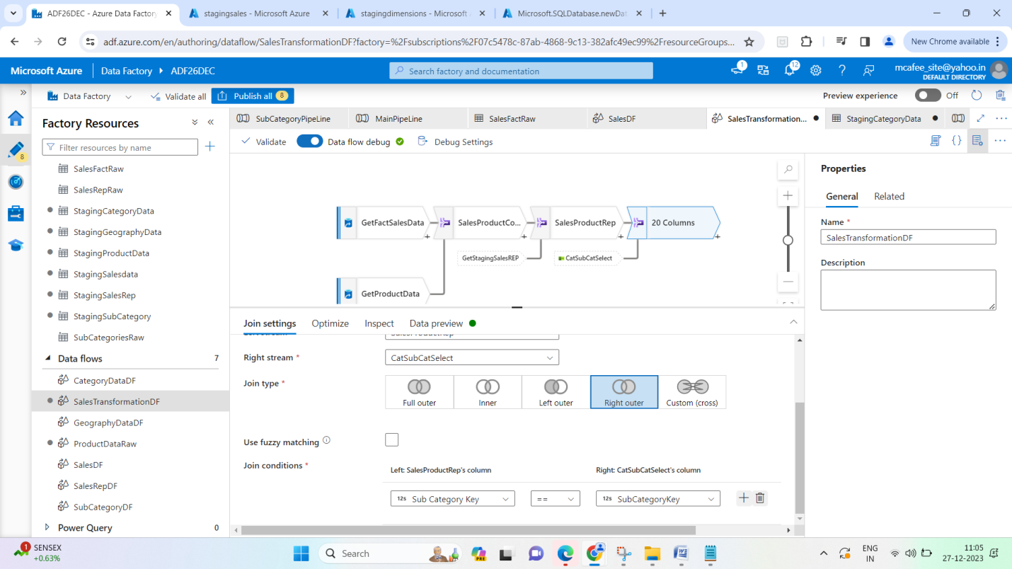

1. Select required columns -

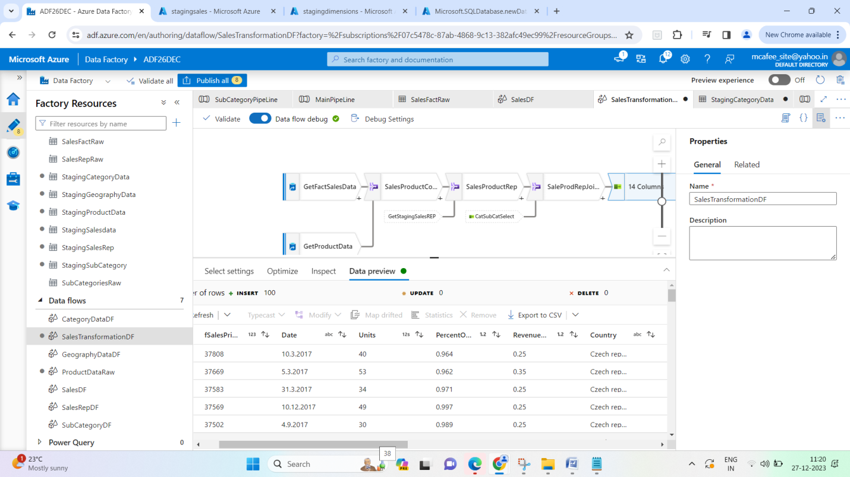

1. Use derived column – for revenue and profit calculation -

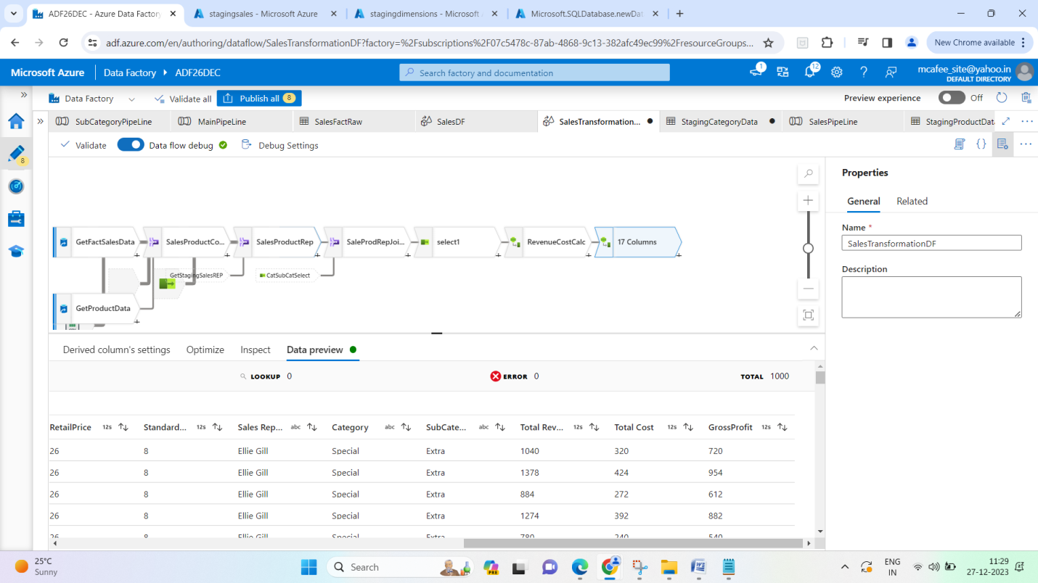

1. Create sink – SQL server

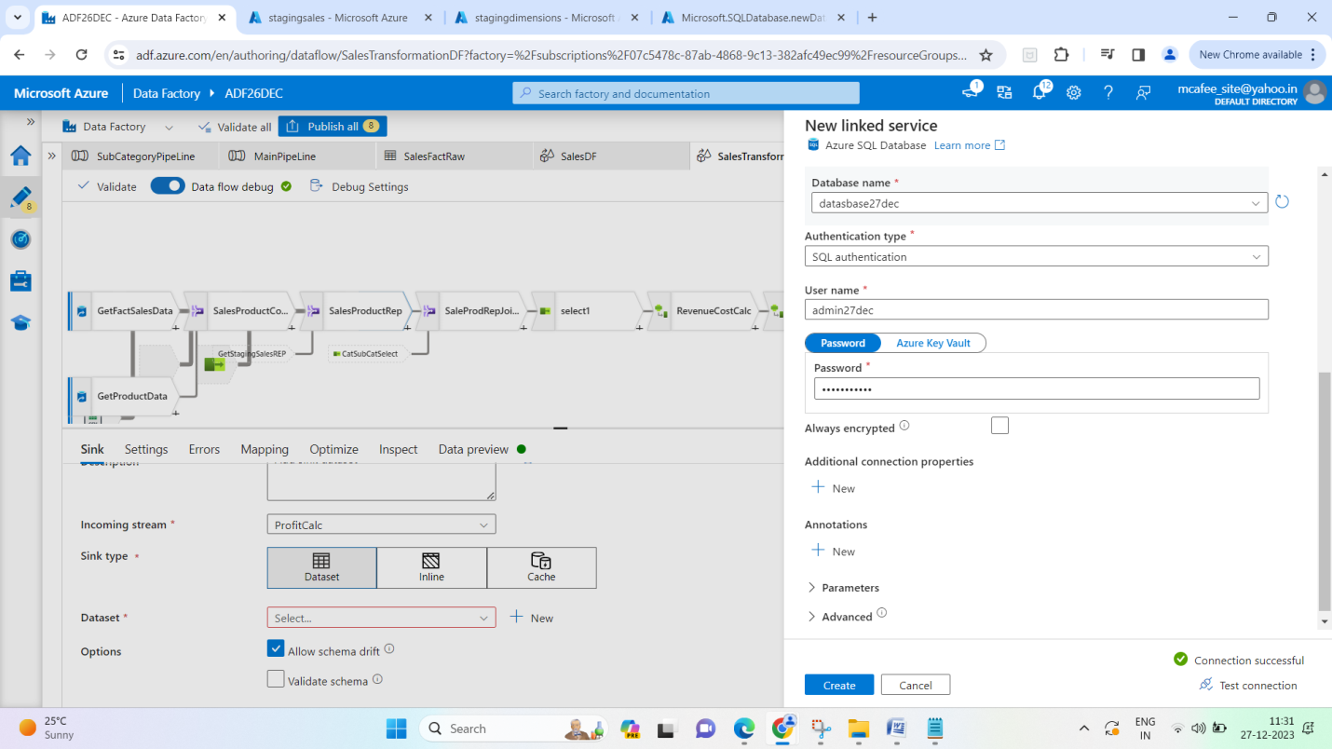

1. Add on execute pipeline for Sales Tranformation Dataflow

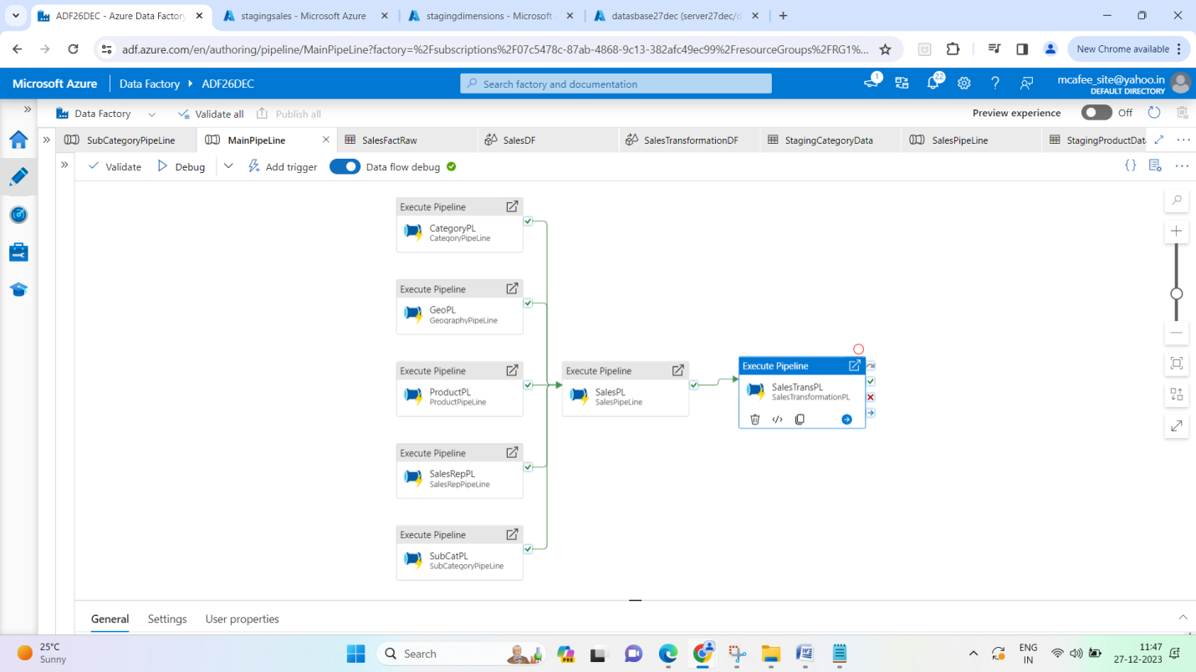

1. Run the full Main Pipeline – check for data in SQL server DB -

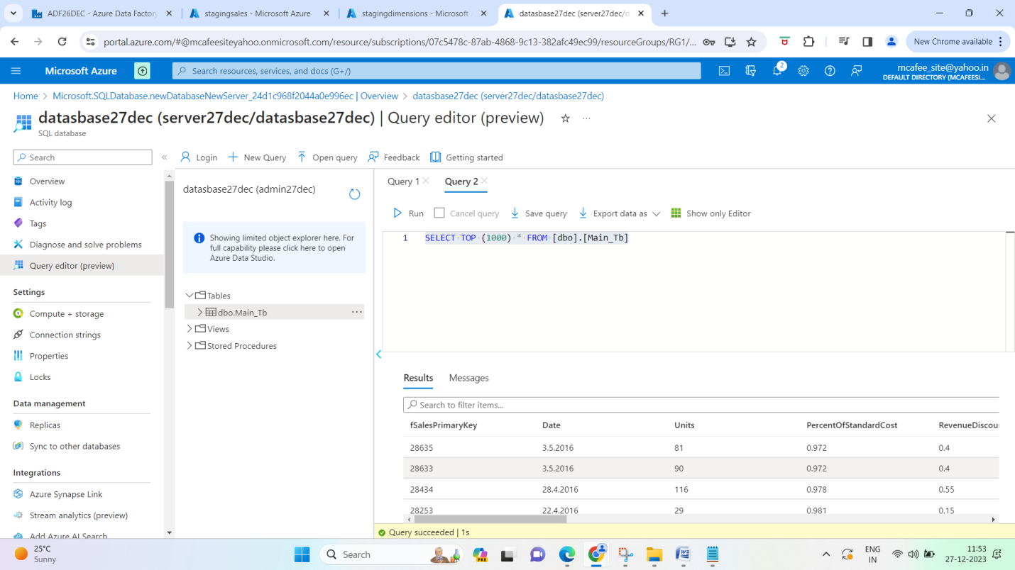

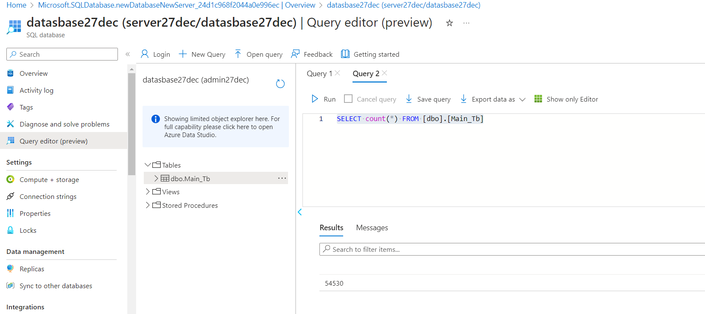

1. Dashboard / BI Reporting -

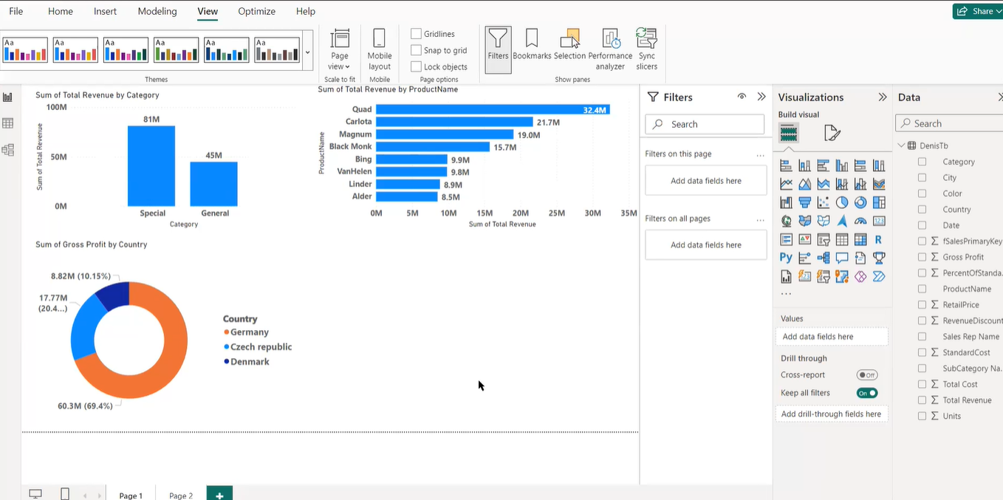

1. Appendix

Reference –

